

**Hands-On Lab**

**Exploring the new z/OSMF Desktop UI**

## Abstract:

IBM z/OS Management Facility (z/OSMF) provides a web-based graphical user interface (UI) for working with z/OS. In this hand-on lab, you will explore the new desktop style UI of z/OSMF, which offers advantages over the earlier, classic style UI.

This session will be useful to systems programmers and their managers who will be using or are considering using z/OSMF.

## Introduction: A new look and feel for z/OSMF

After ten years of continuous development, the z/OSMF user interface (UI) is showing its age. The current UI, with its navigation tree, tabs, and tables, is still quite functional, but it has some notable limitations. For example, the current UI limits you to running one z/OSMF task at a time. Also, it constrains the size of each task work area---the place where you do your z/OS work---which can make it a chore to enter commands and data.

Is it time for a change? We think so. With the installation of APAR PH16076 and the subsequent enhancements on your system, z/OSMF now offers a new, desktop-style UI as a user-selectable option. Since z/OS V2R5, desktop-style UI is the only supported UI for z/OSMF.

With this new UI comes a new way of interacting with z/OSMF, which is more consistent with other computing platforms. The changes include:

* Much larger work area with icons to represent the z/OSMF tasks and folders.
* Task bar that helps you access z/OSMF tasks quickly.

Your experience is further enhanced through the following improvements:

* Support for a mix of new and existing applications.
* Multi-tasking capabilities for viewing and running multiple tasks at once.
* Ability to:
  + Resize the workspace of a particular task within the UI.
  + Create customized groupings of z/OSMF tasks in user-named folders.
  + Save links from the Links task as icons on the desktop.
  + Search, browse and edit data sets, Unix directory and Unix files.
  + Create shortcut for data set, UNIX files on the desktop.
  + Submit data set or data set member as JCL.
  + View job output for your jobs.
  + Create new data set or USS file.
  + Open multiple search window.
  + Compare dataset and USS file.
  + Download/Upload Data Set, Data Set member, or USS file.

We think that you will find the new desktop UI to be faster and more friendly to use than the earlier, classic style UI.

**z/OSMF Lab: Exploring the desktop style UI**

In this lab, you will learn about the new desktop UI by completing the following activities:

1. Log in to z/OSMF.

2. Create new data set.

3. Create a new data set member.

4. Search data set and member.

5. Copy and rename data set member.

6. Compare and merge data set members.

7. Browse USS path and edit USS file.

8. Open referenced data sets in Editor.

9. Create shortcut for data set or data set member.

10. Download/Upload Data Set, Data Set member, or USS file.

It is recommended that you perform these activities in the order listed. As you become more familiar with the desktop UI, you will become adept at accessing the particular tasks that you require.

As with the other labs in this session, the lab teams share access to the same z/OS system. Each team is given a unique z/OS user ID to use for the exercises. To avoid confusion, use only the user ID that is assigned to your team.

**Notes:**

1. The screen captures in this handout show the use of different user IDs. Your browser session will use the user ID that was assigned to your lab team.
2. Log in to z/OSMF

* Launch browser from your workstation
* Point browser to z/OSMF – enter the following url

<https://share.centers.ihost.com/zosmf>

* Login with SHARE userid/pw as provided by the lab instructor
* Each workstation has been assigned a unique z/OS user id

Note: All screen captures in the handout show the different user ID, your browser will be slightly different to reflect the User ID that you were given.

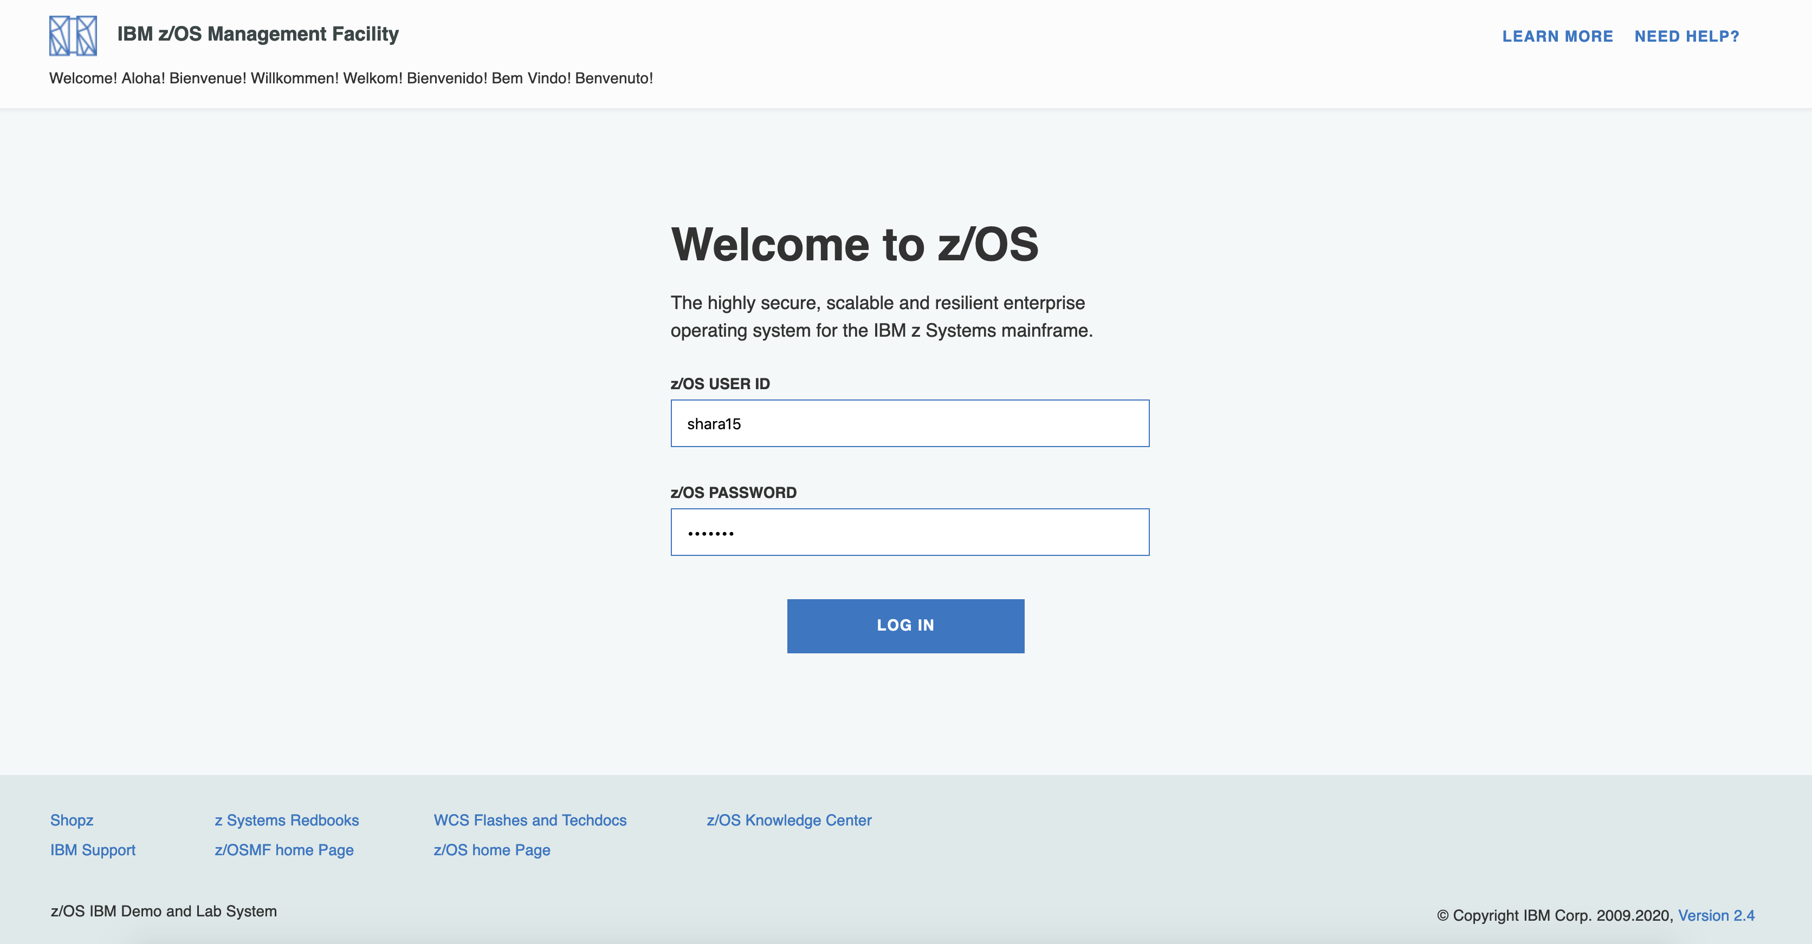

Since V2R4, z/OSMF lands in desktop UI by default.

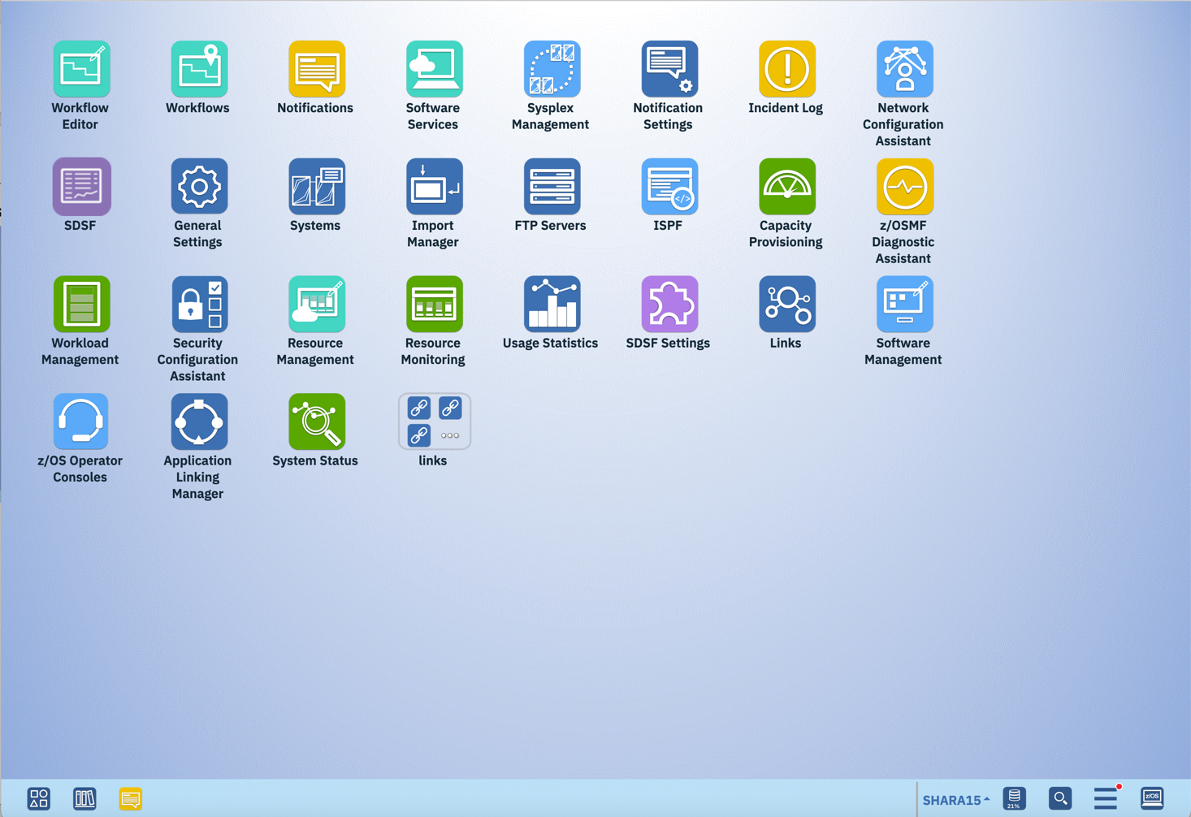

1. Create new data set

Step 2a. Open the dialog of Create new data set

Right click on the z/OSMF desktop background, and select NewàData set menu. 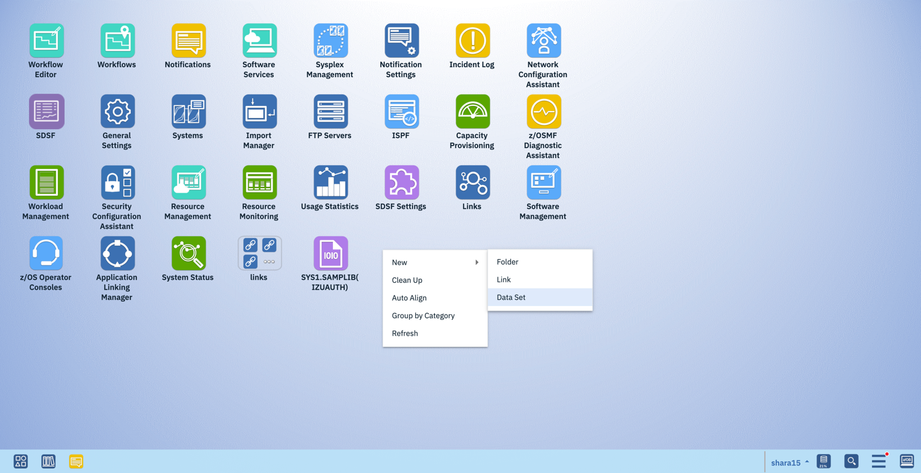

The “New Data Set” dialog will be popped up.

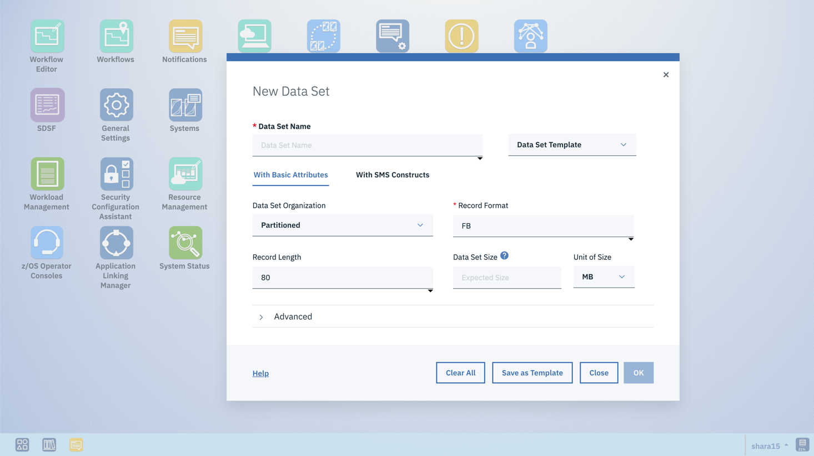

Step 2b. Create a PDS/E dataset with pre-defined template for JCL data set

In the dialog of “New Data Set”, enter data set name <userid>.LAB.DEMO in which <userid> should be replaced by your current logon user id, such as SHARA15. Then select “JCL” template in the “Data Set Template” drop down list.

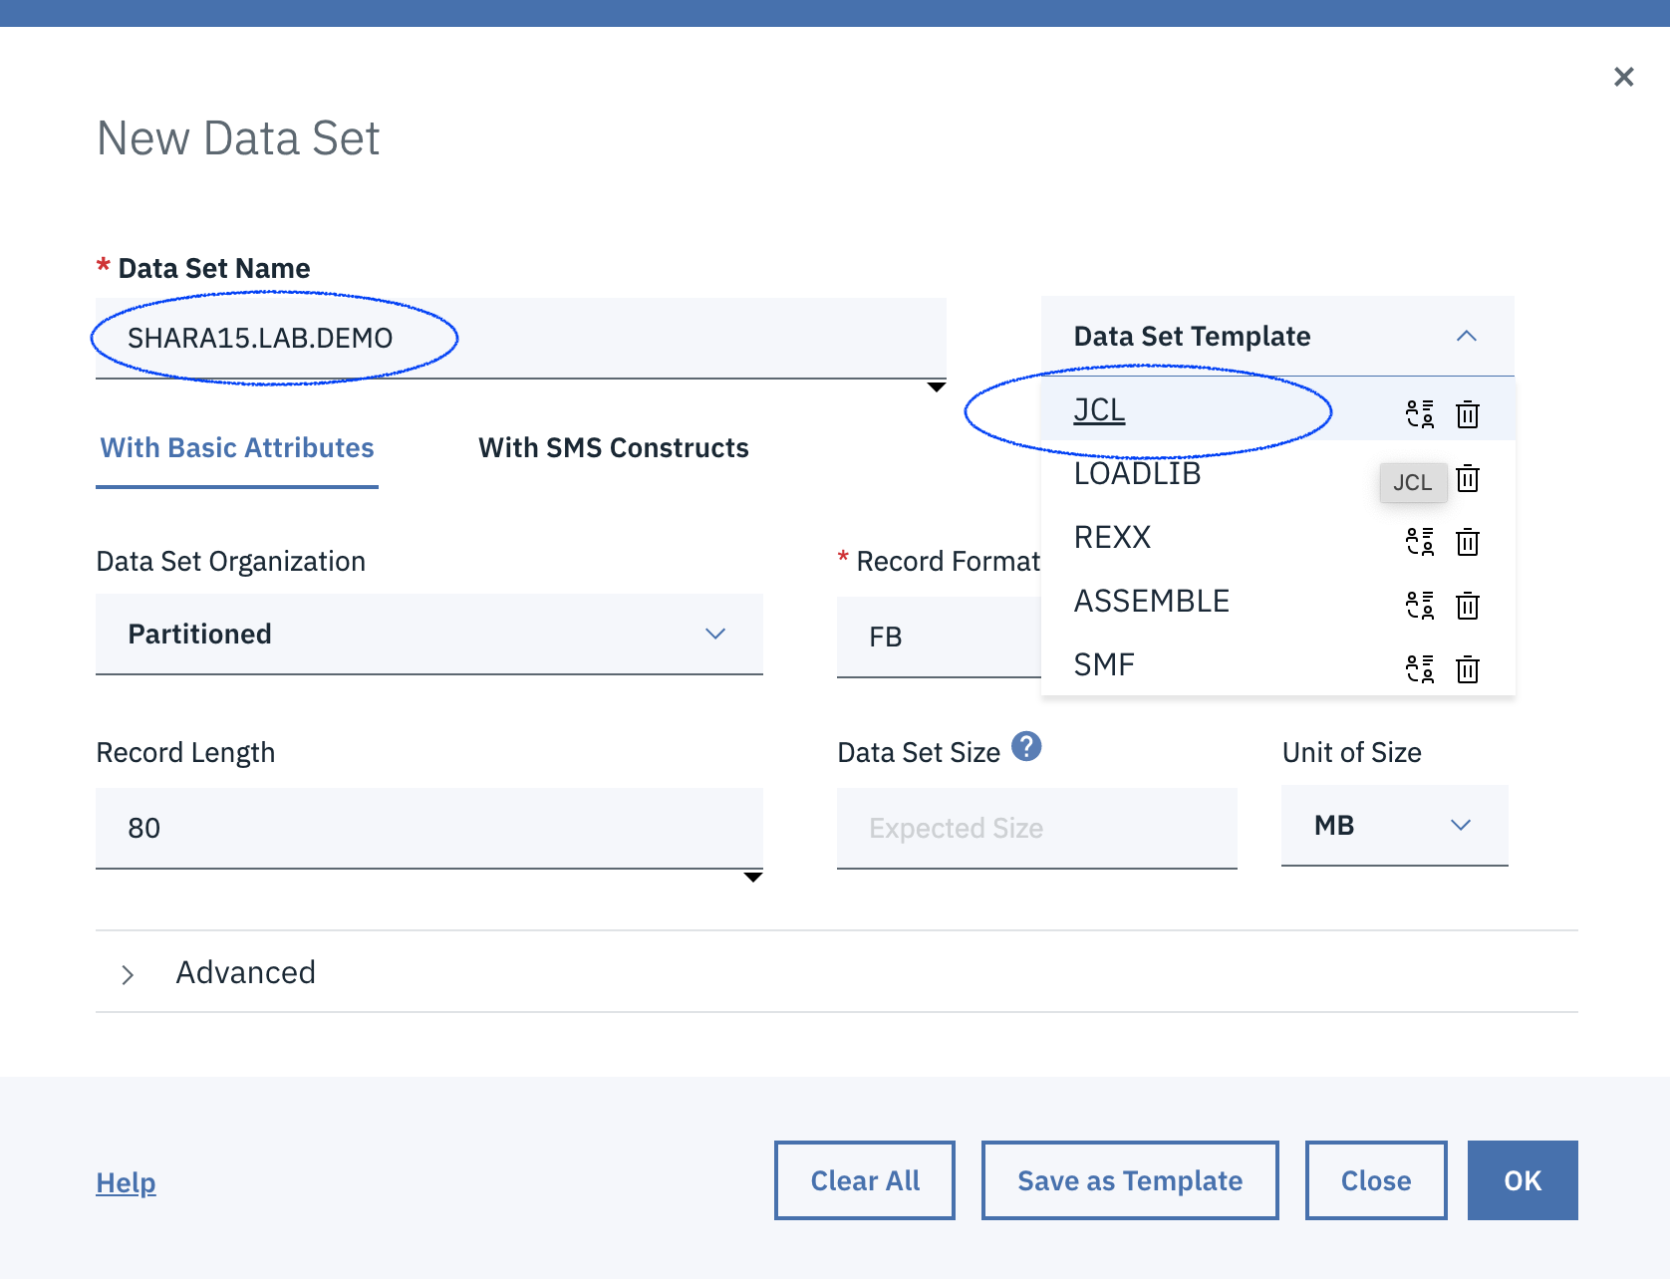

Click on OK button, the data set will be created and a new message will be displayed on the top of the dialog to indicate the successful creation of the new data set.

Step 2c. Open the created data set

In the popped up message, click the Open button in the message to directly access the data set just created.

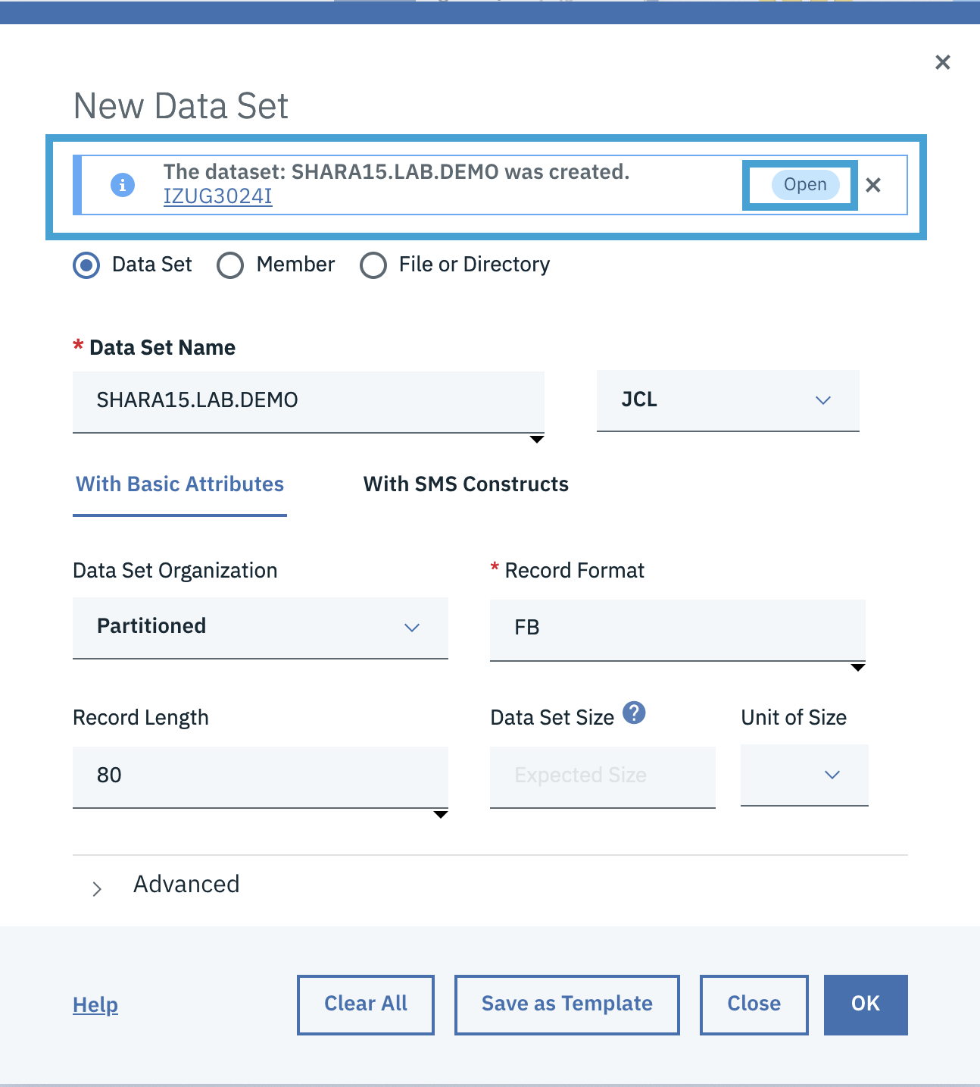

The panel will display member list of this data set. Since it’s just created, there is no member displayed in the dialog.

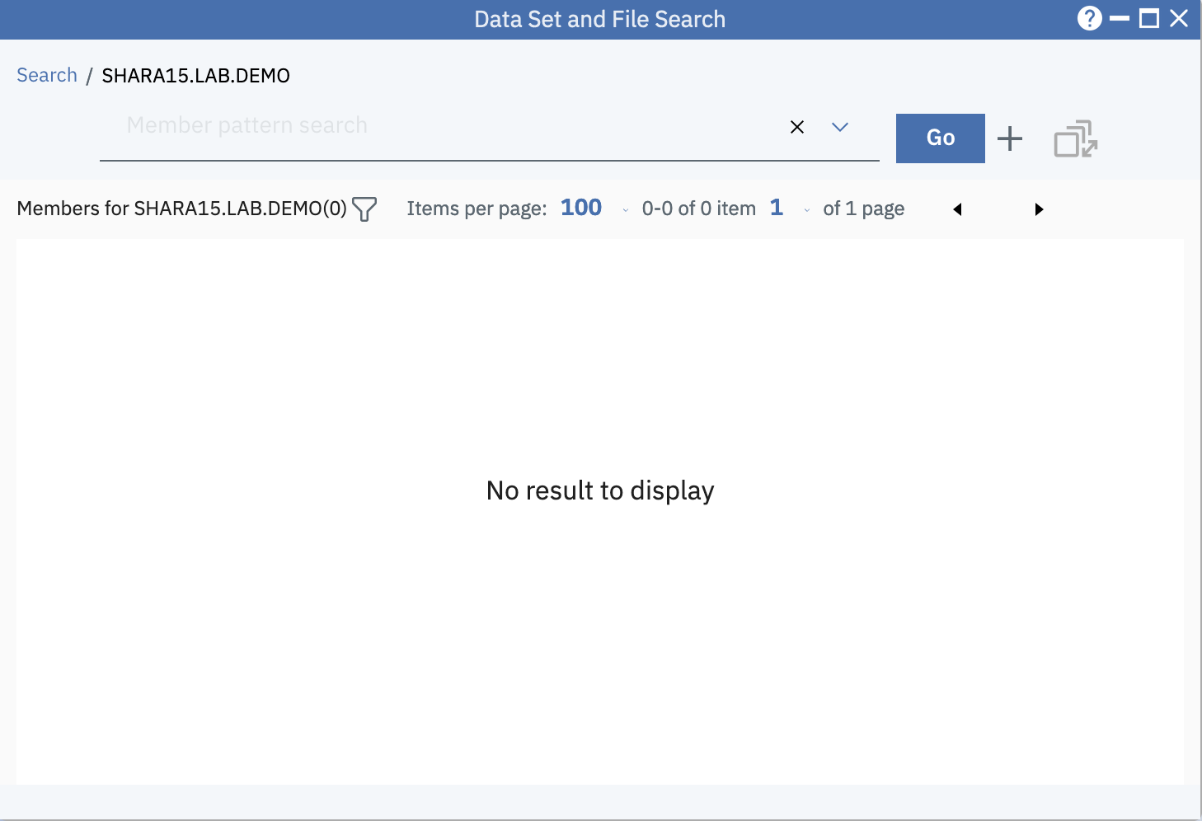

1. Create a new data set member

Step 3a. Open New Member dialog

Click the + icon like below to open the New Member dialog.

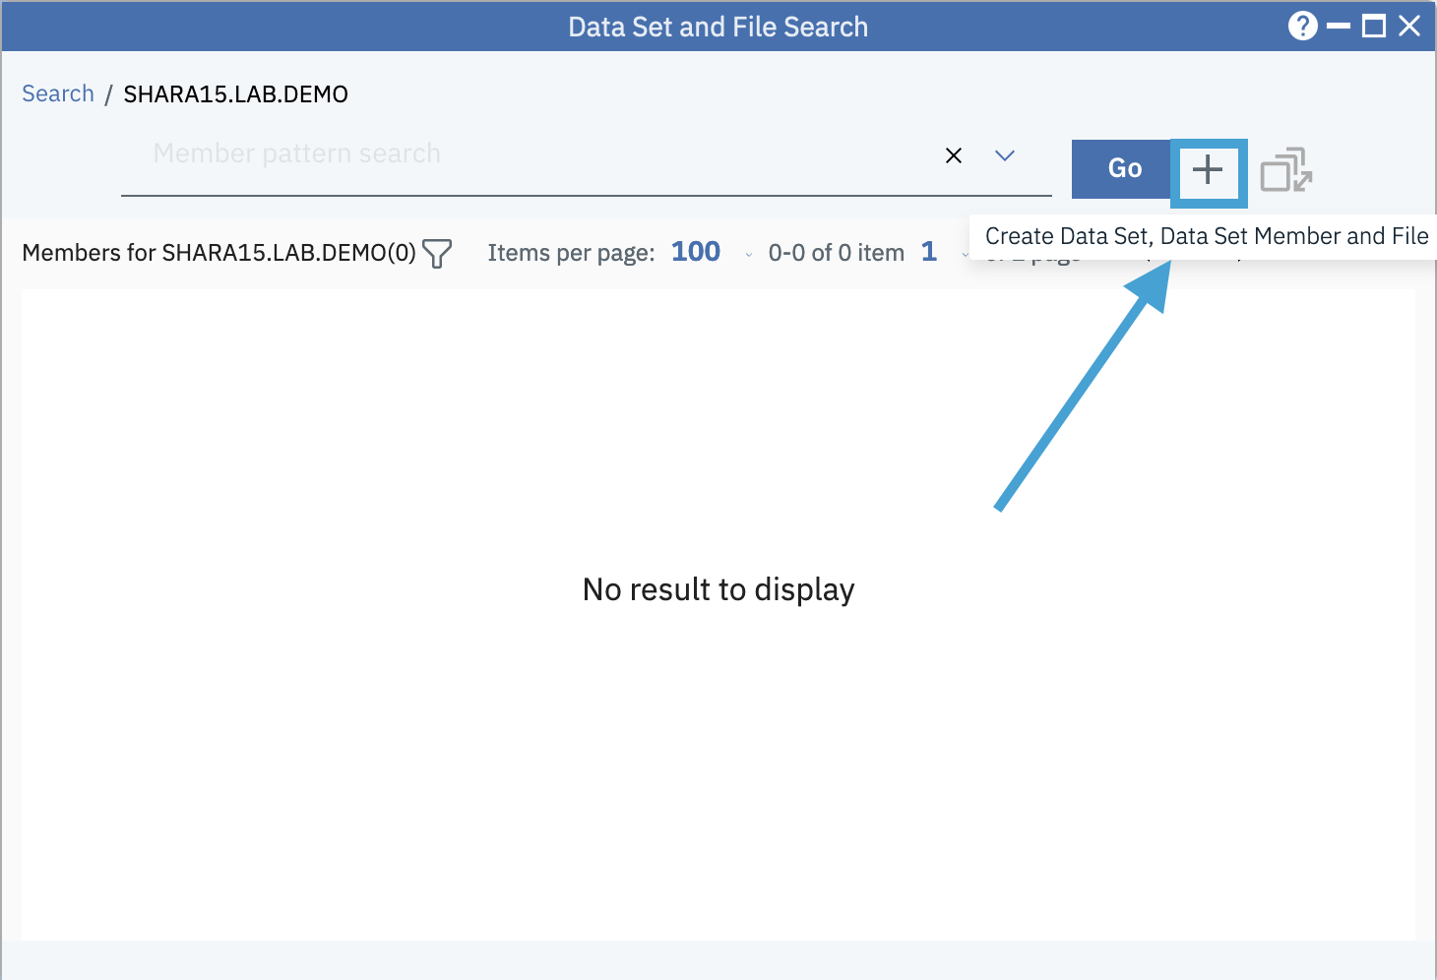

A new dialog is opened and the current data set name is populated.

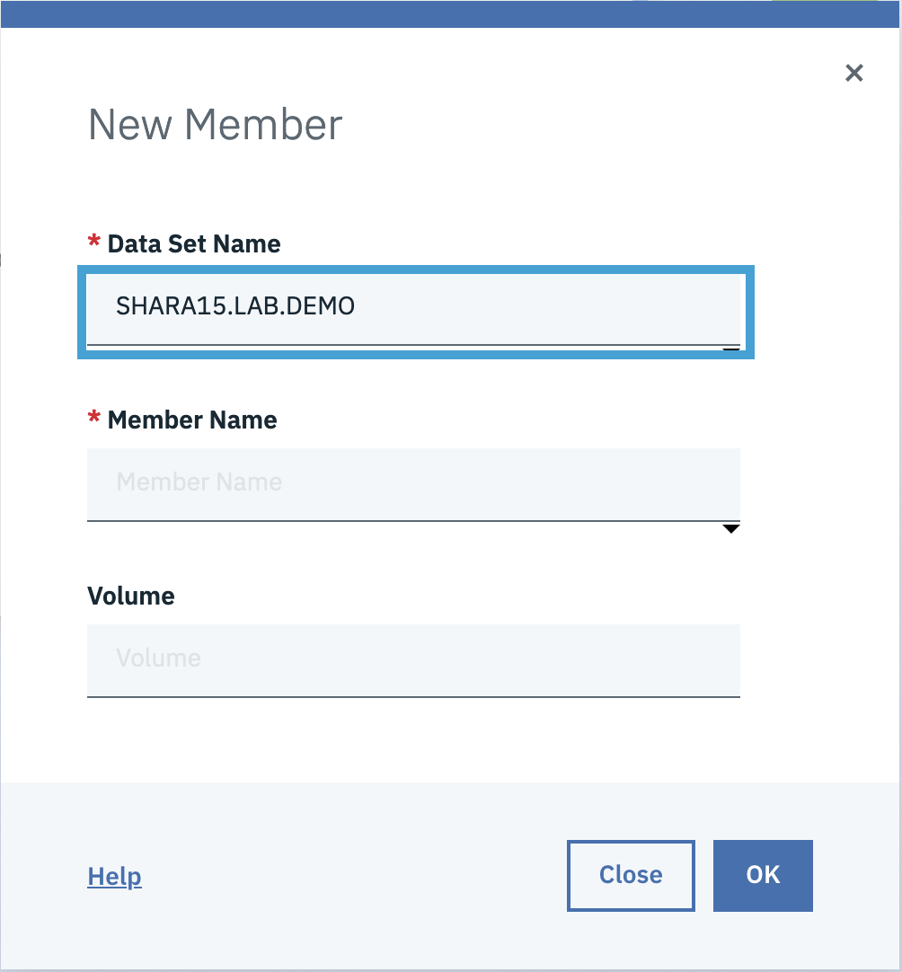

Step 3b. Create a new member

Input TEST as the Member Name value, then click OK.

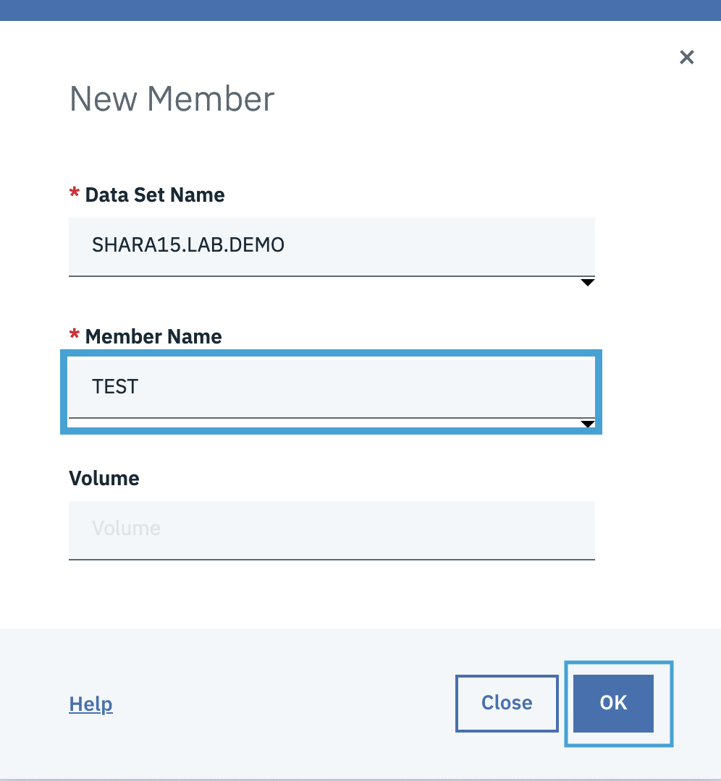

Step 3c. Check if the data set member is created successfully

Click Open in the message to open the data set member just created.

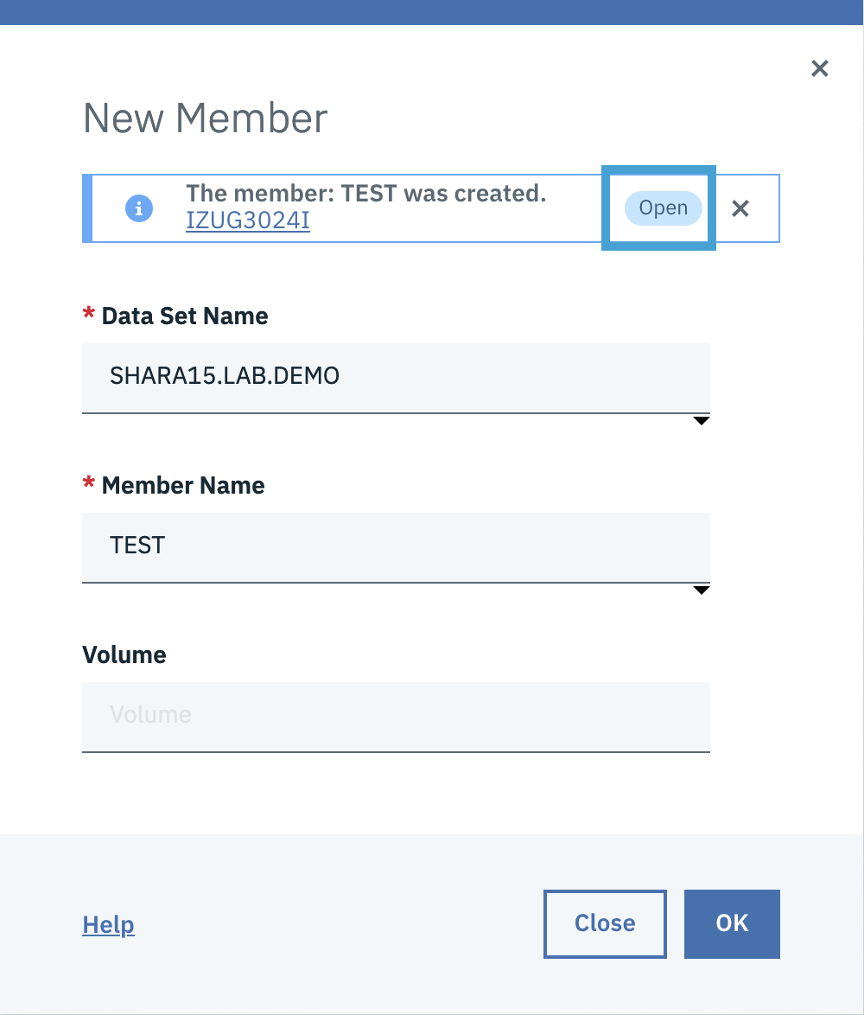

Now, you will see the editor window of data set member “SHARA15.LAB.DEMO(TEST)”.

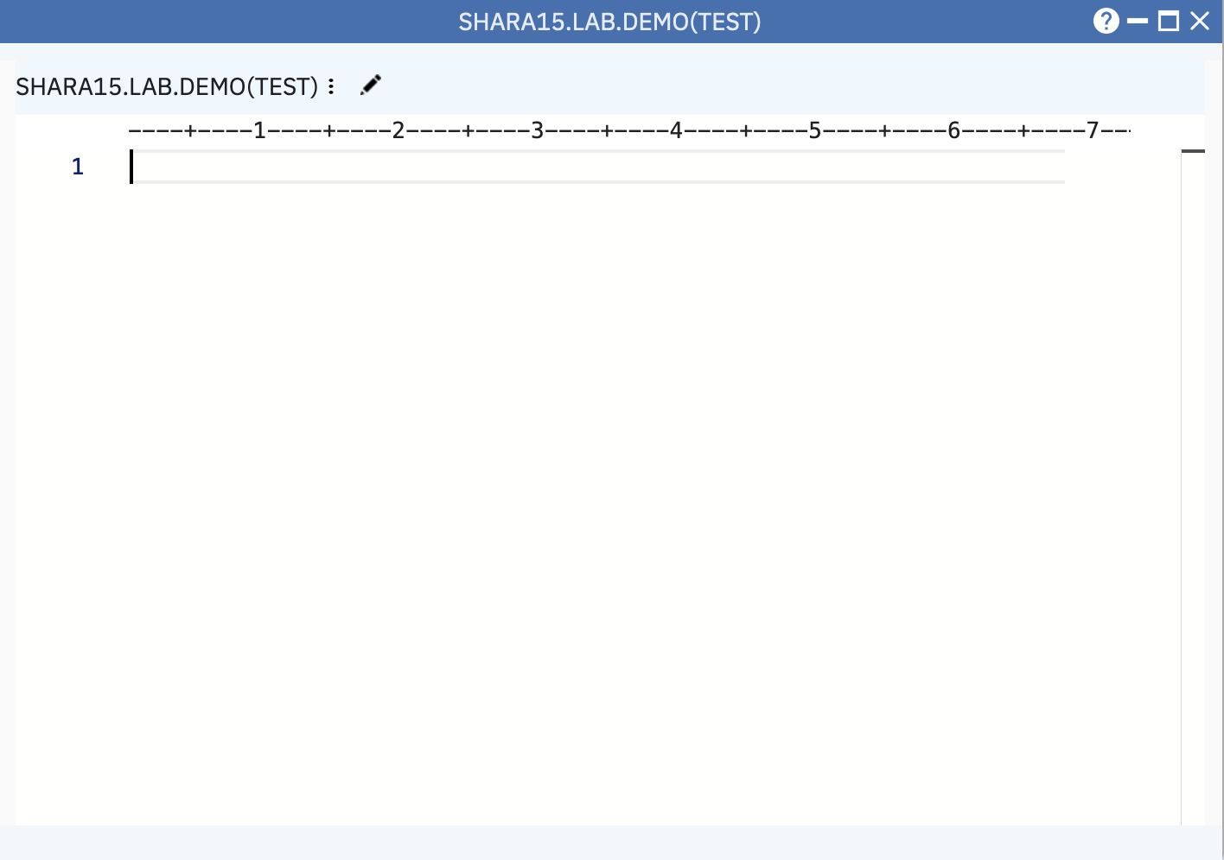

Let’s close the Editor window for now.

1. Search data set and member

Step 4a. Open a new search window and search data set SYS1.SAMPLIB with type ahead search function

* Select the “New Search Window” from the Data Set and File Search to open one more search window.
* Input sys1.s in the search box and pause for one second. You will see the drop down list which contains all the data set names match with “SYS1.S” you just entered.
* Use Up or Down arrow key in keyboard to scroll up and down in the drop down list.
* Select SYS1.SAMPLIB and hit enter.

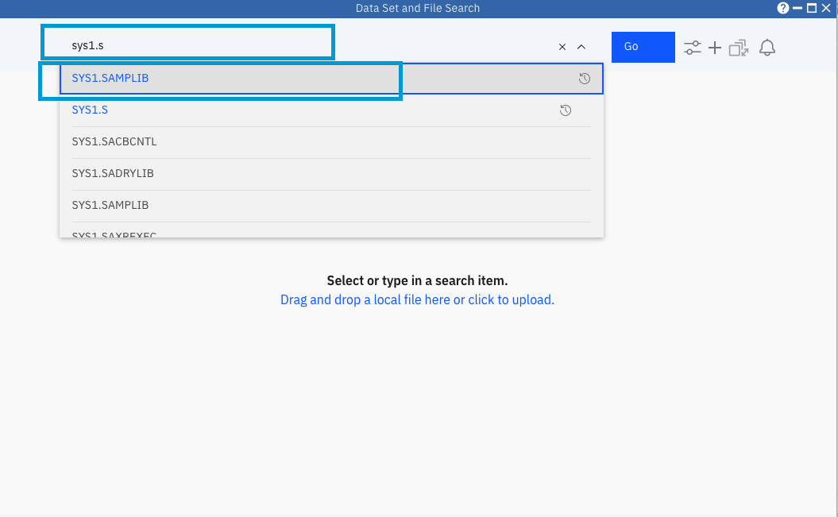

Step 4b. List the data set SYS1.SAMPLIB

Click Go button or press Enter.

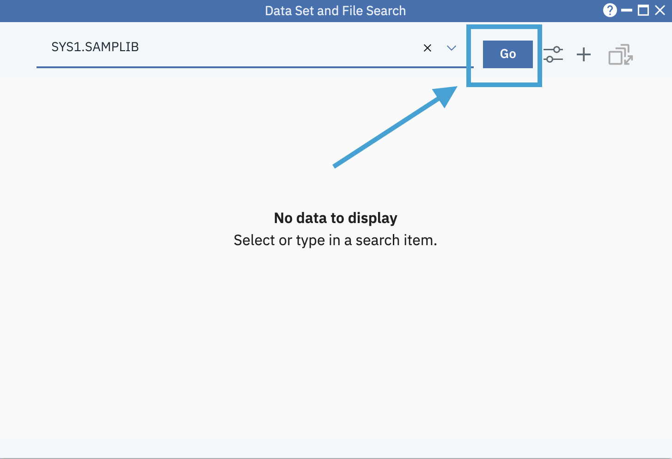

Step 4c. Open member list of data set SYS1.SAMPLIB

Click on the data set name to open it. Since SYS1.SAMPLIB is a PDS/E, the member list will be displayed.

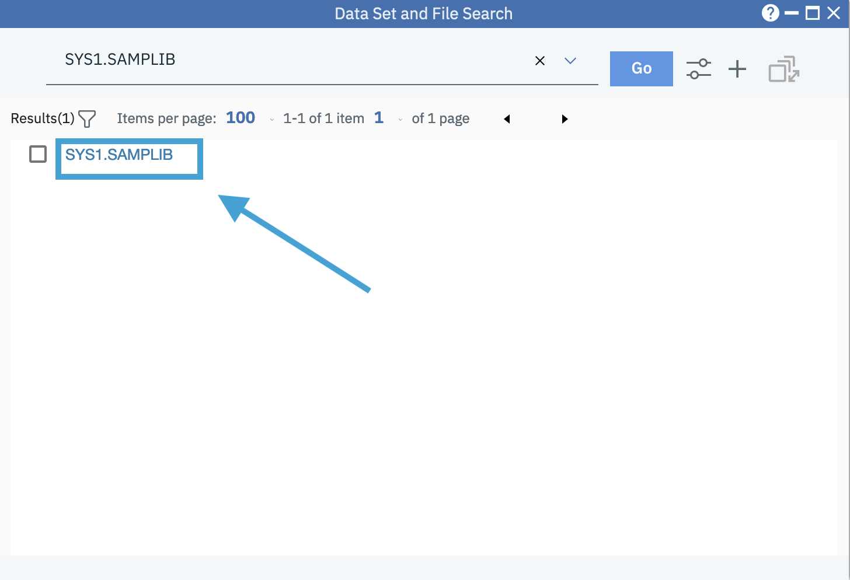

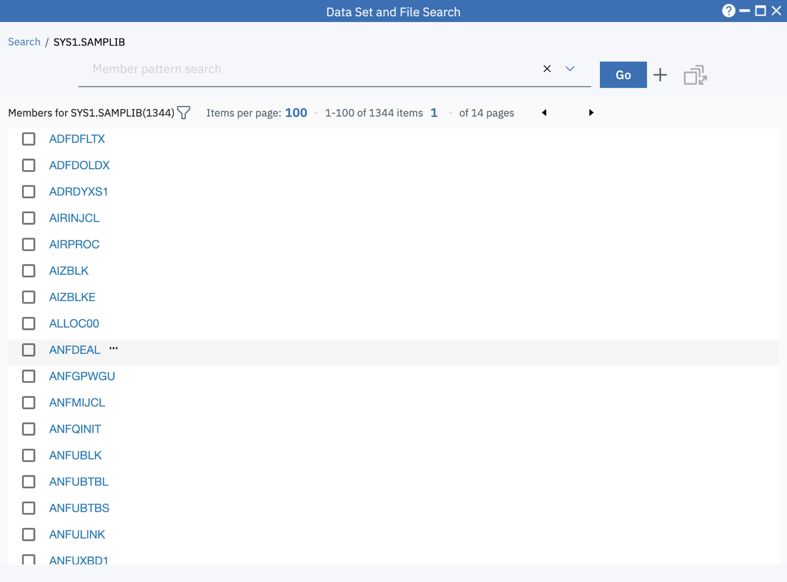

Step 4d. Use Filter to quickly locate data set member AIRINJCL

Click the Filter icon on the tool bar

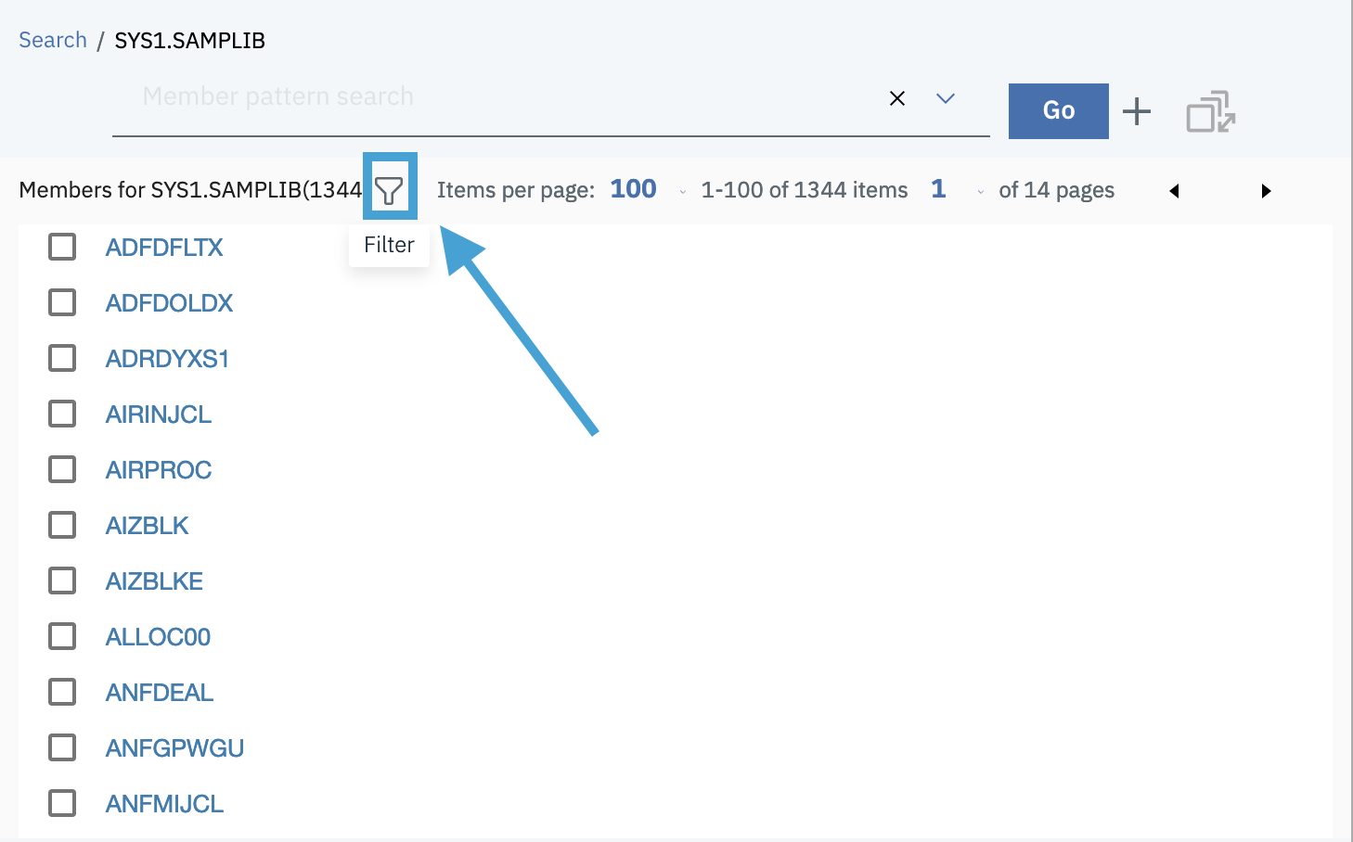

Input keyword “JCL” in the Filter input box to quickly locate the member “AIRINJCL”.

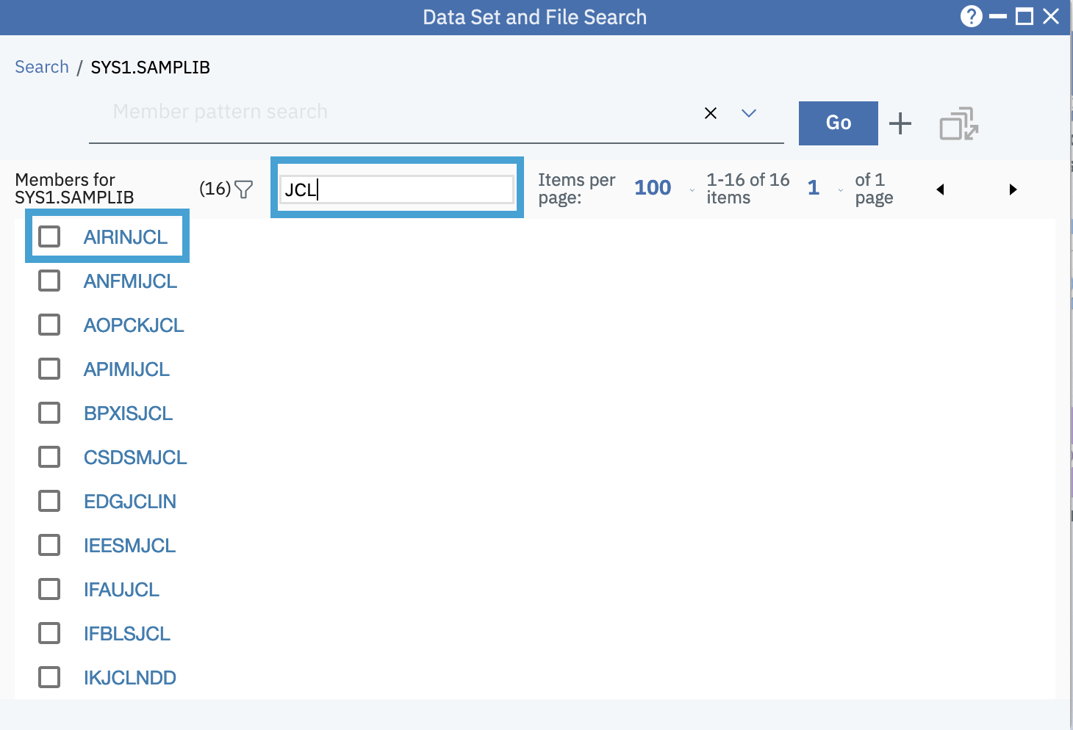

1. Copy and rename data set member

Step 5a. Copy data set member AIRINJCL from SYS1.SAMPLIB to SHARA15.LAB.DEMO

* Right click on the data set member AIRINJCL, then select Copy to à Data Set.

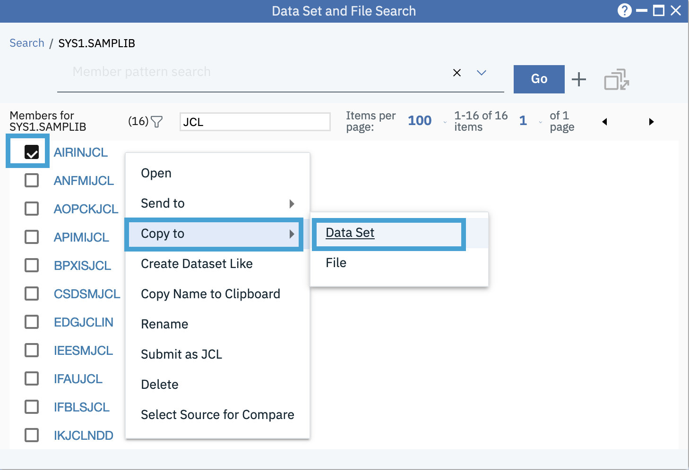

* Input <USERID>.LAB.DEMO and the Member Name as TEST. Then click OK button.

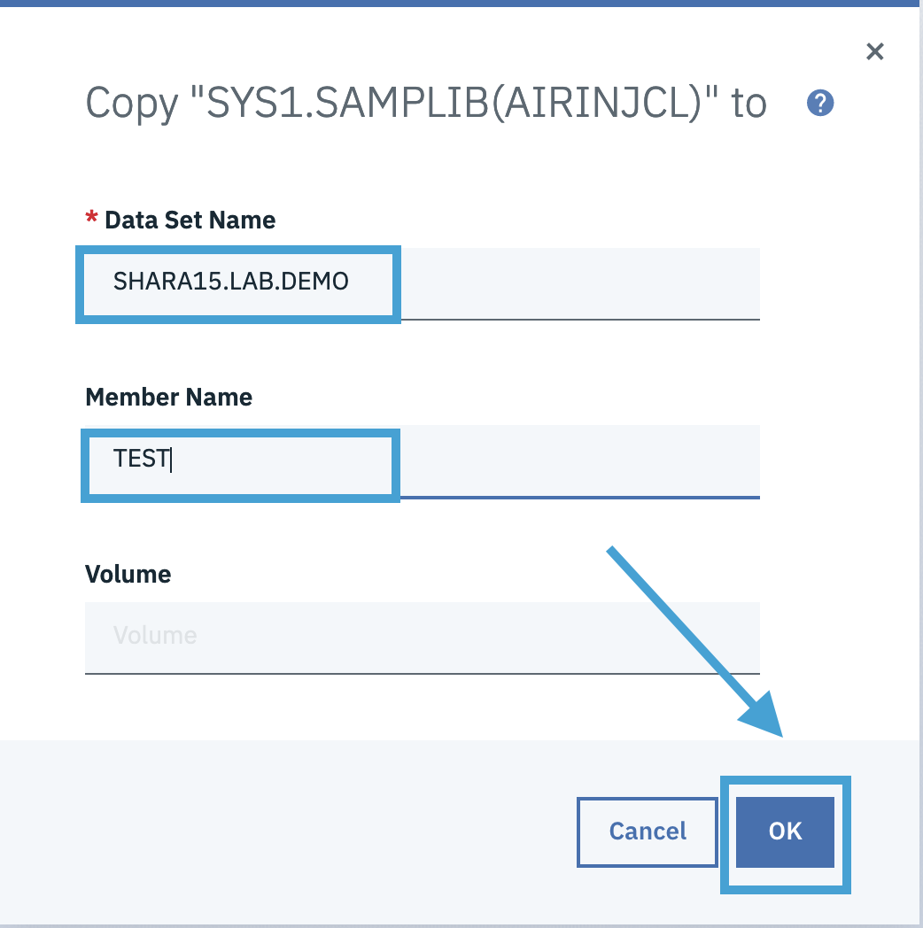

Step 5b. Check the result of Copy

Switch back to “SHARA15.LAB.DEMO” window from “Data set and File Search” dialog like below.

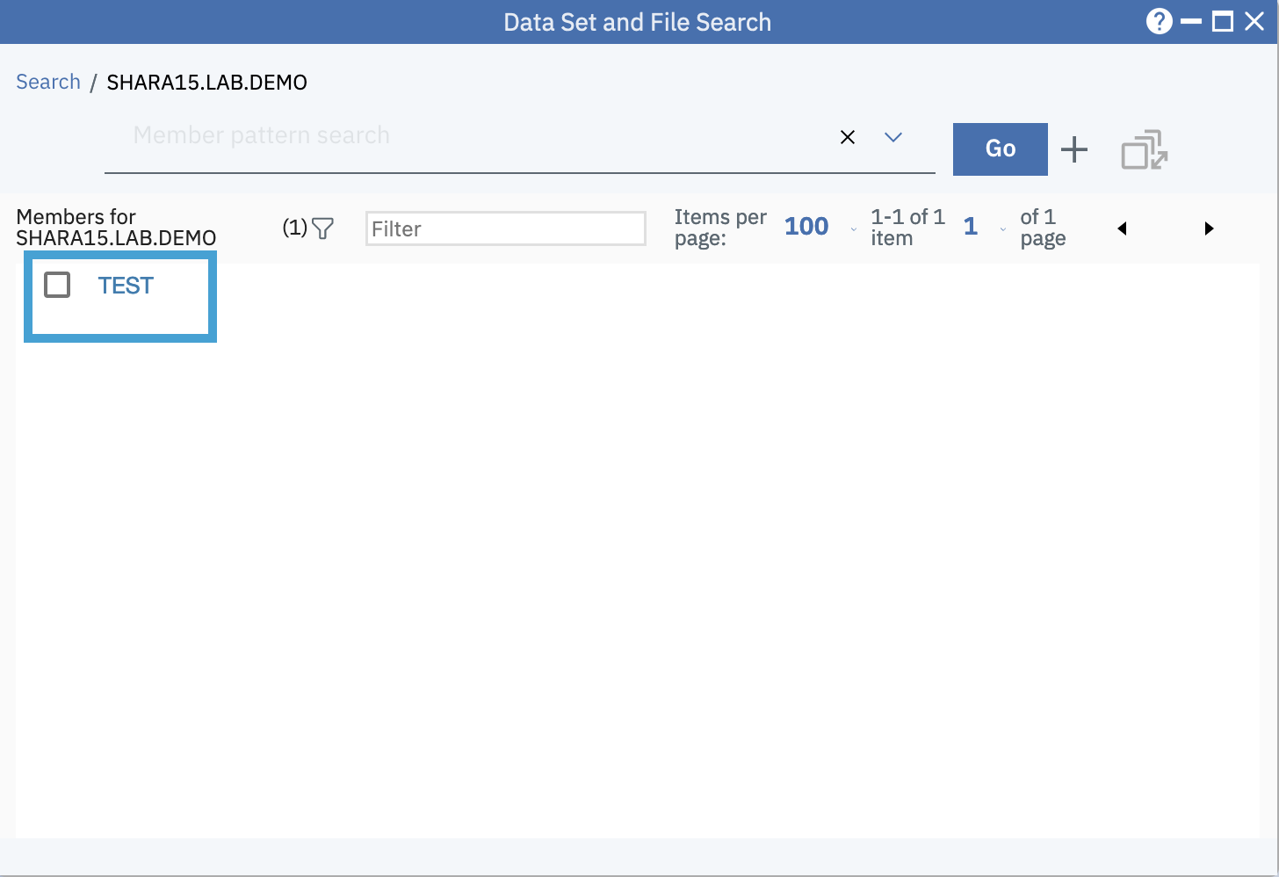

Step 5c. Rename the data set member SHARA15.LAB.DEMO(TEST)

* Right click on the member “TEST” and select “Rename”

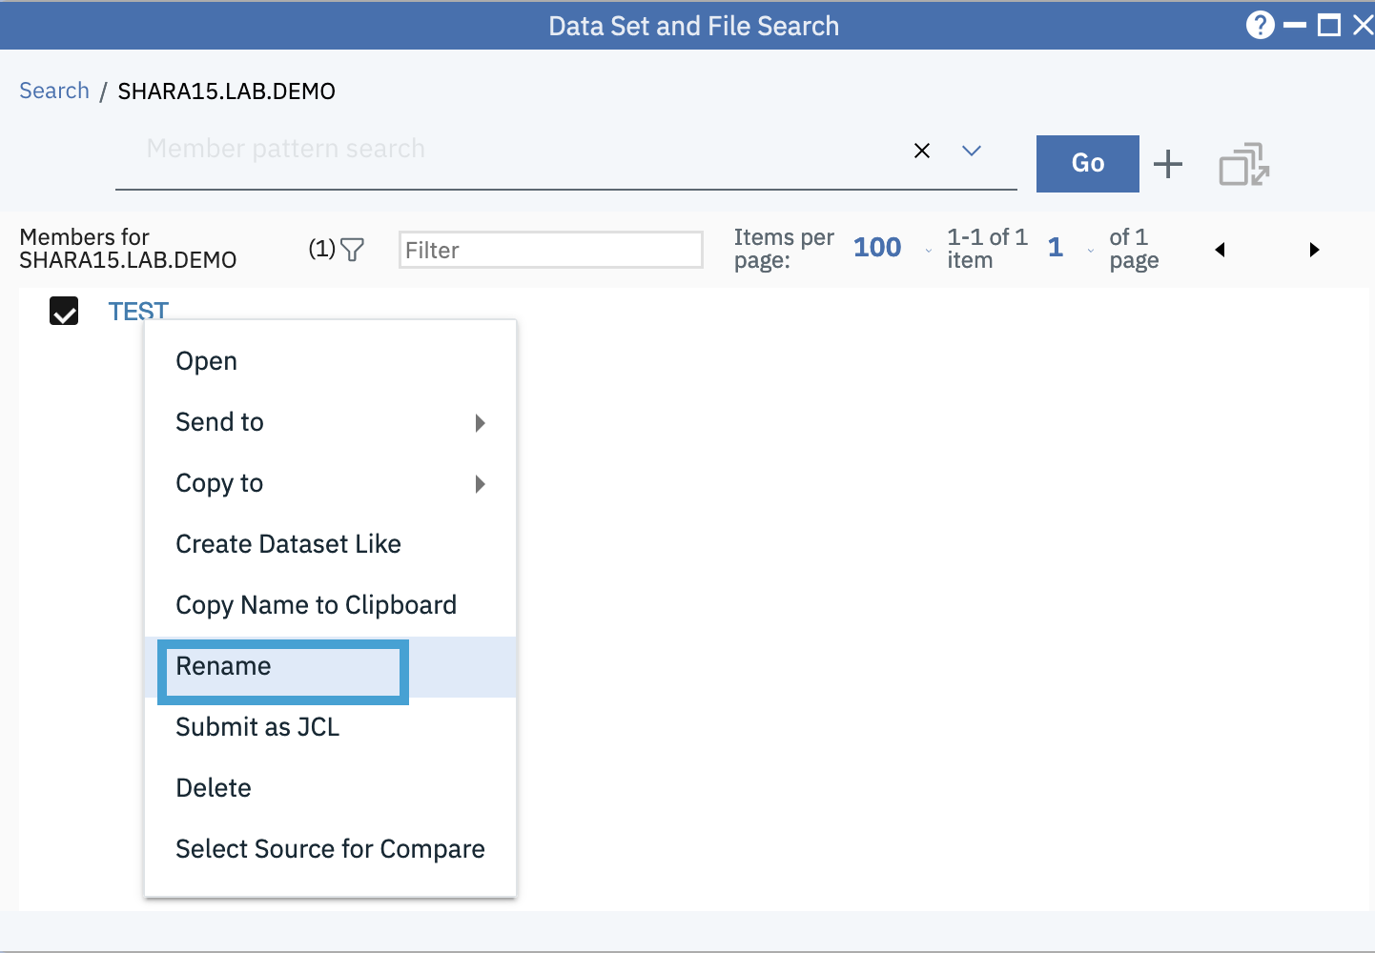

The Rename dialog will be opened. Provide a new name “AIRIN2” like below. Hit OK button.

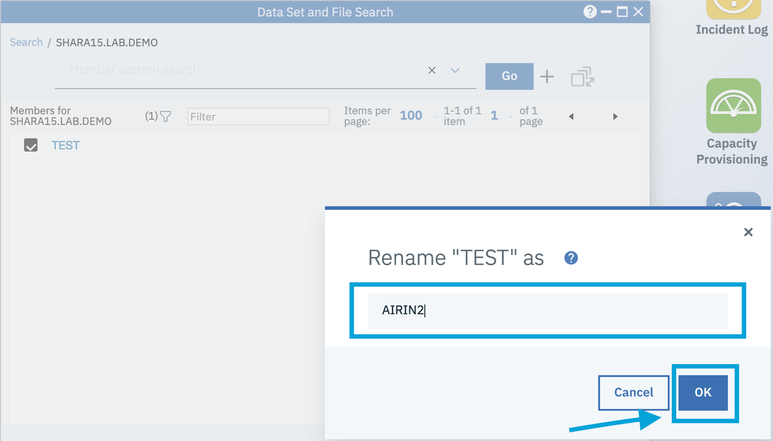

Step 5d. Edit content of data set member

Switch back to the “Data set and File Search” dialog and click on the member name “AIRIN2” to open the member for editing.

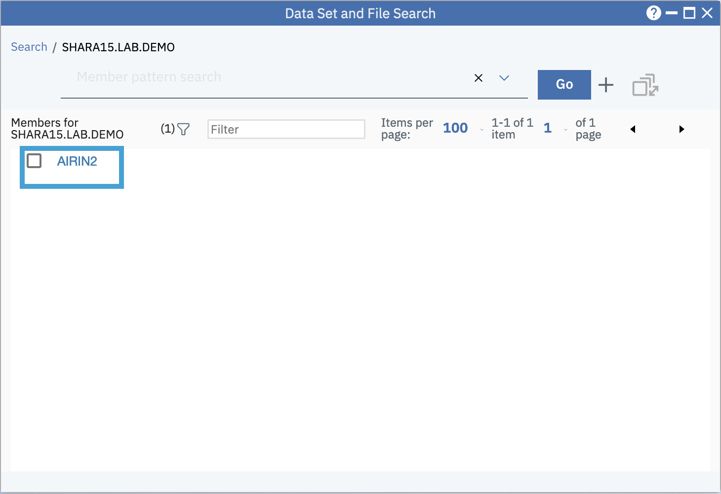

A new editor window will be opened like below. Click on the Pen icon to enter into Editing mode.

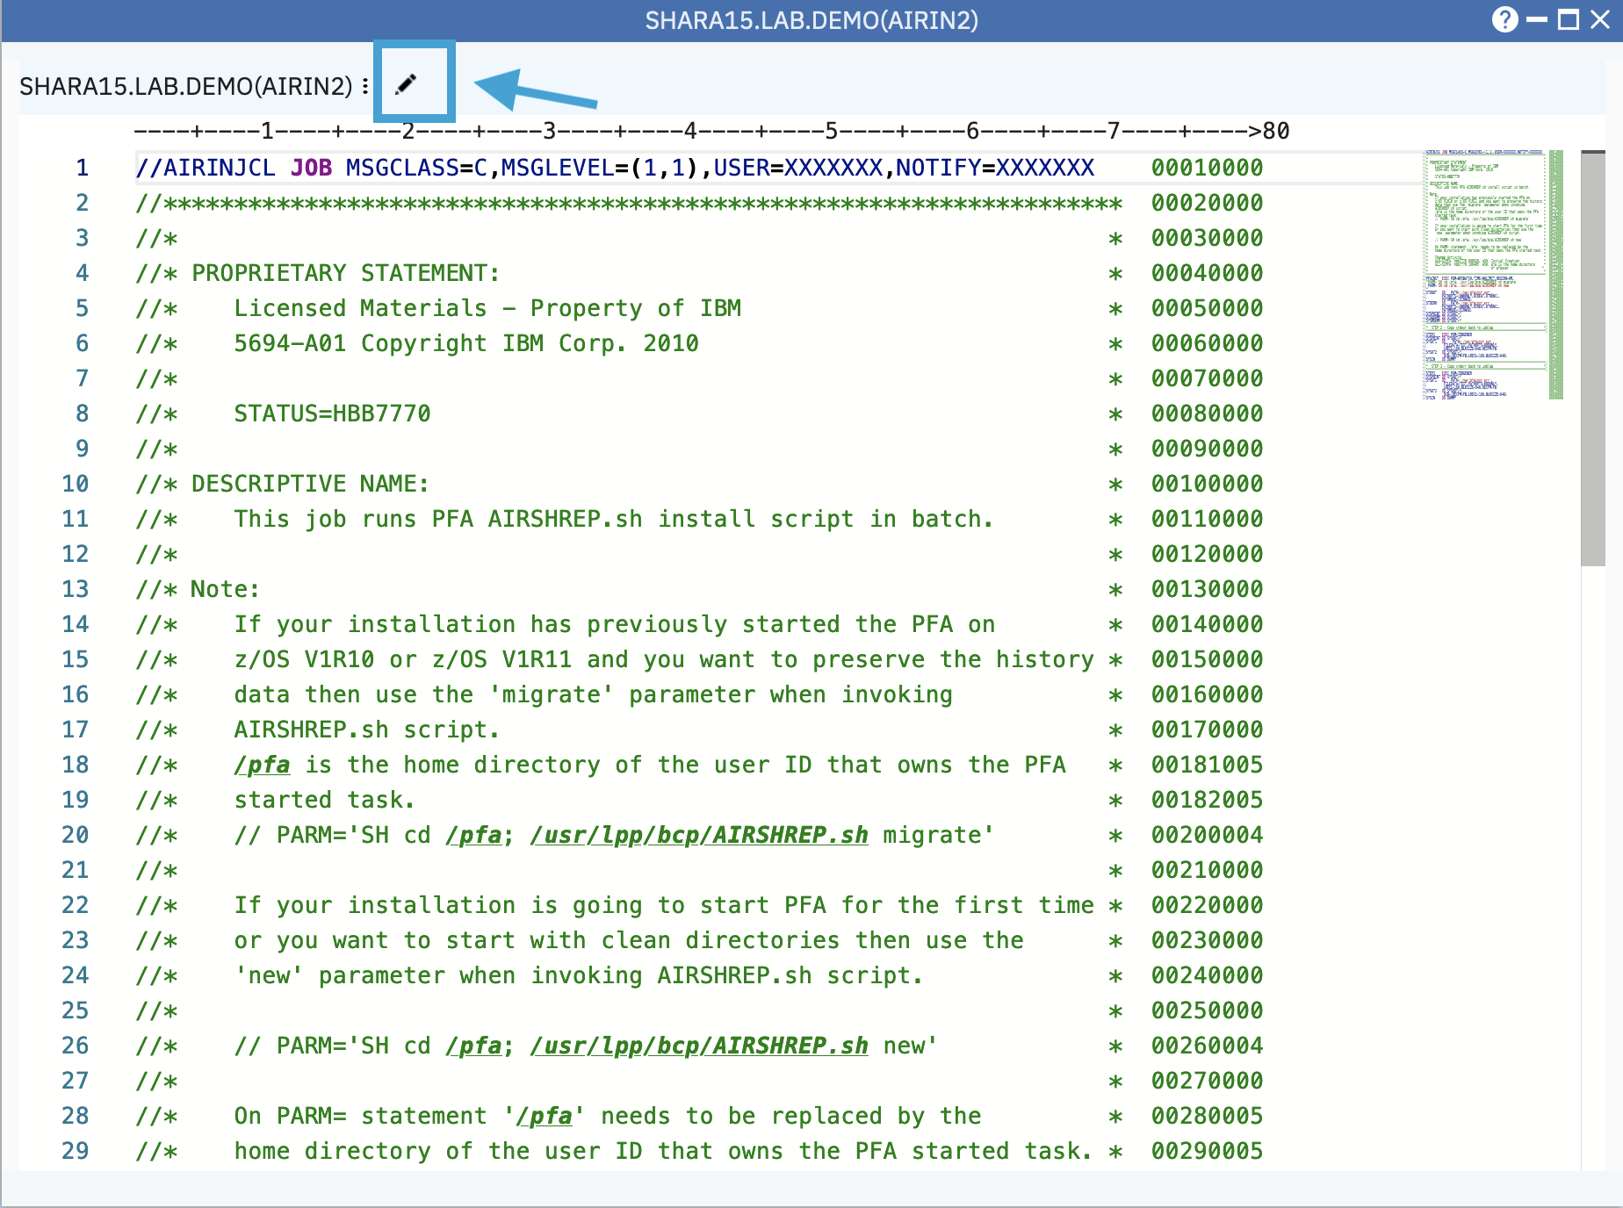

Press Control + F Key (on Windows) to open the Find + Replace tool. (Mac is Command + F).

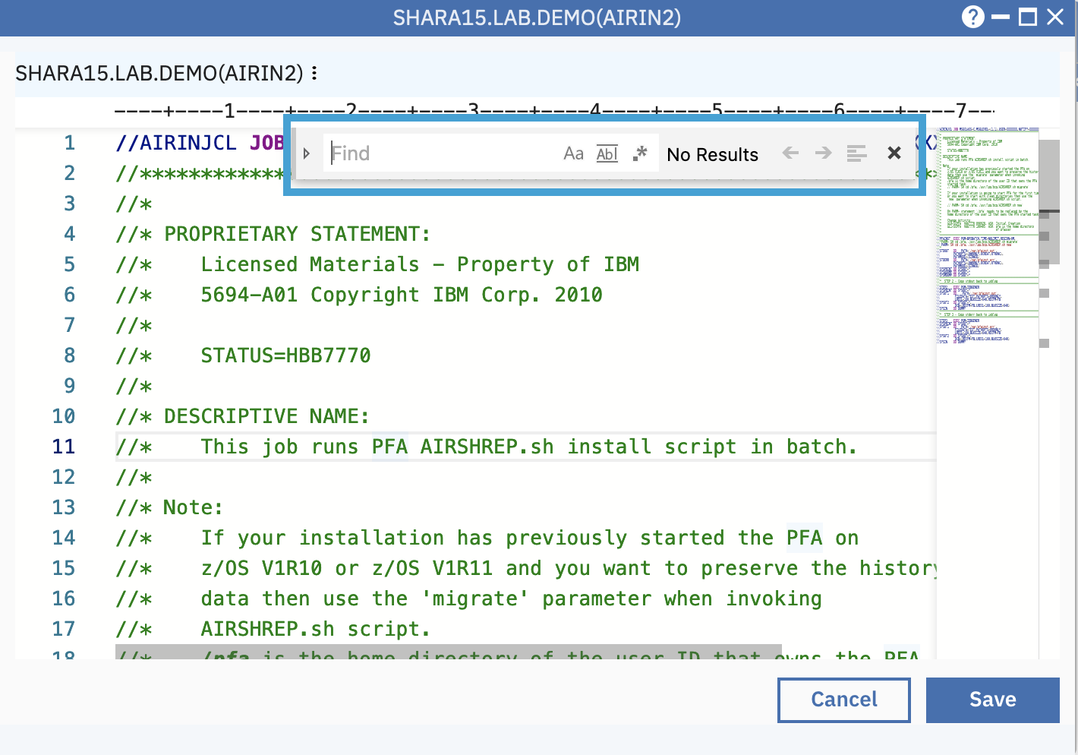

Input tmp in Find box to search the content which contains “tmp”.

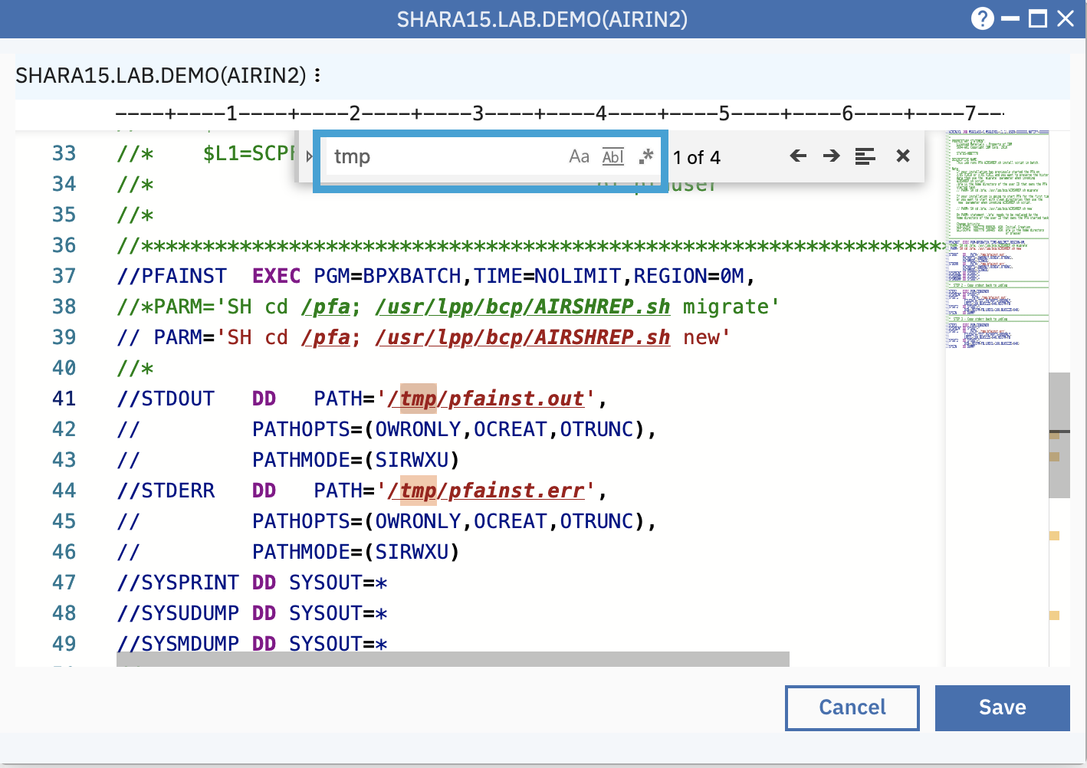

Click the Toggle Replace mode.

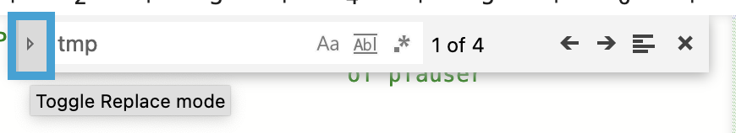

Input “var” in the replace box and click the Replace All icon to change all “tmp” to “var”.

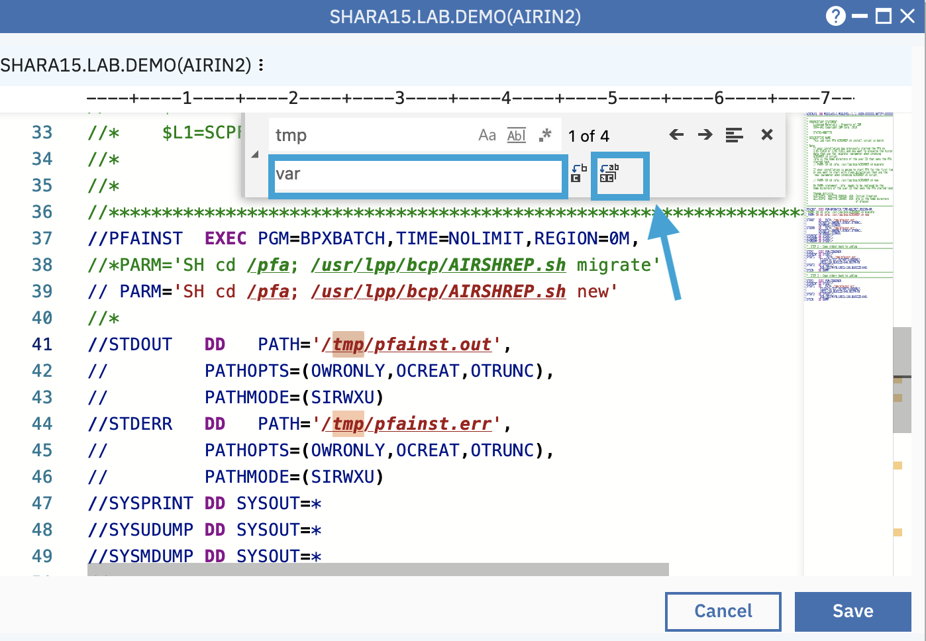

Click the Save button to save changes.

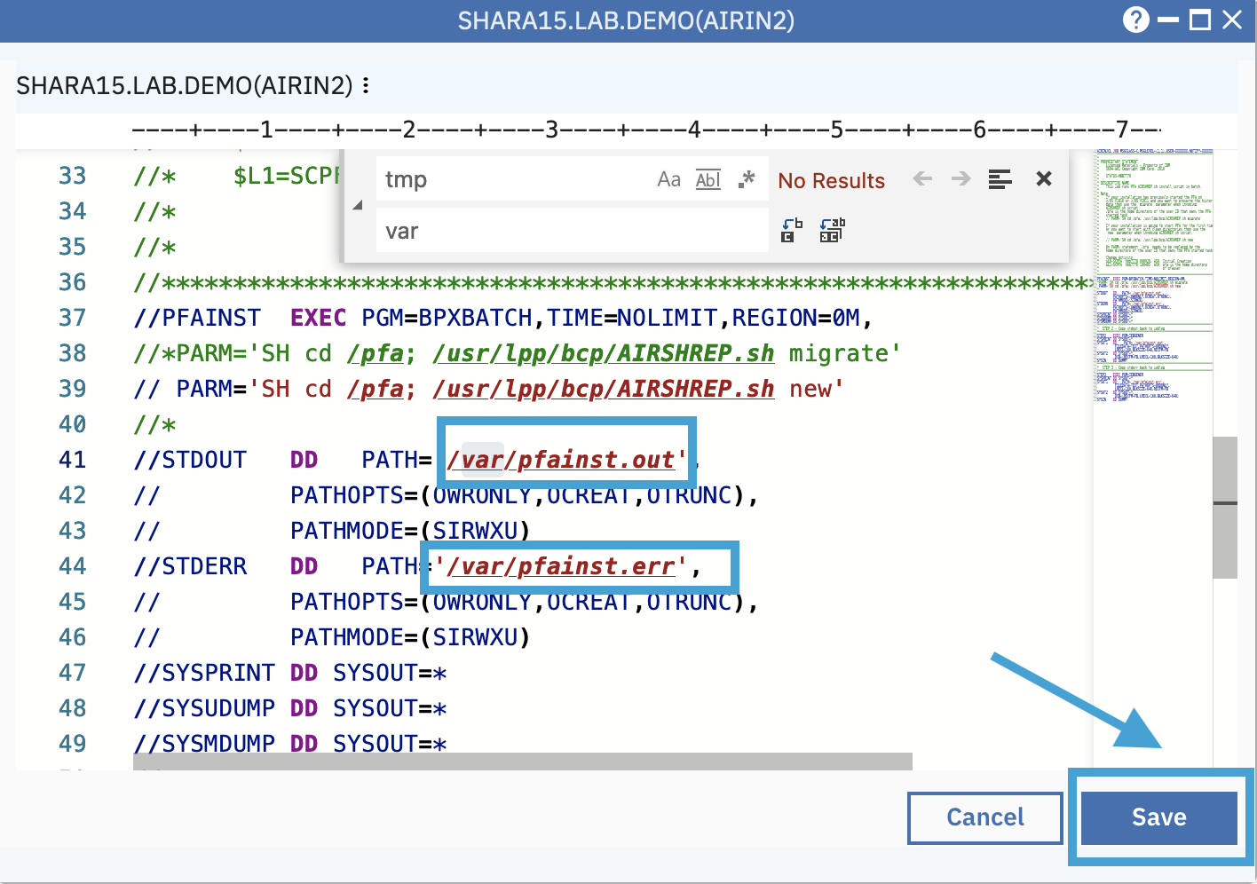

1. Compare and merge data set members

Step 6a. Select source for compare

* Reselect the Data Set and File Search window.
* Select dataset member AIRIN2 à right click à select menu “Select Source for Compare”.

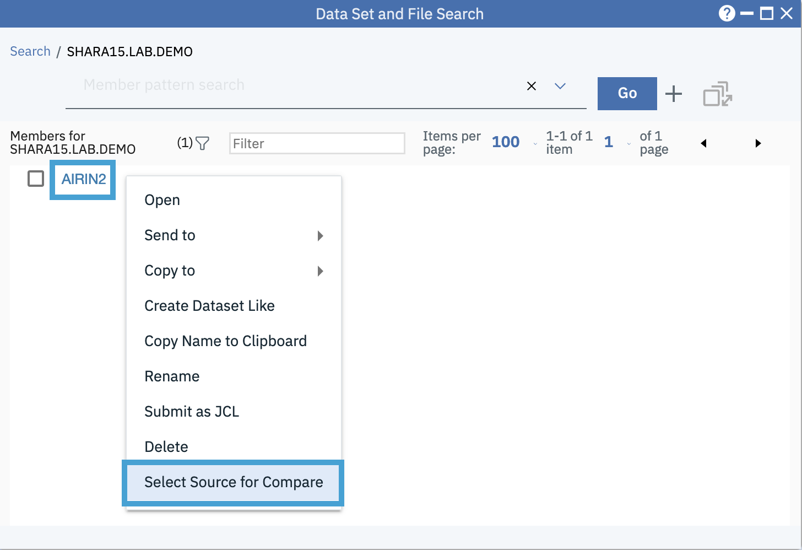

Step 6b. Select another source for compare

* Move the cursor to the search input box.
* Select “SYS1.SAMPLIB” from the dropdown history list.

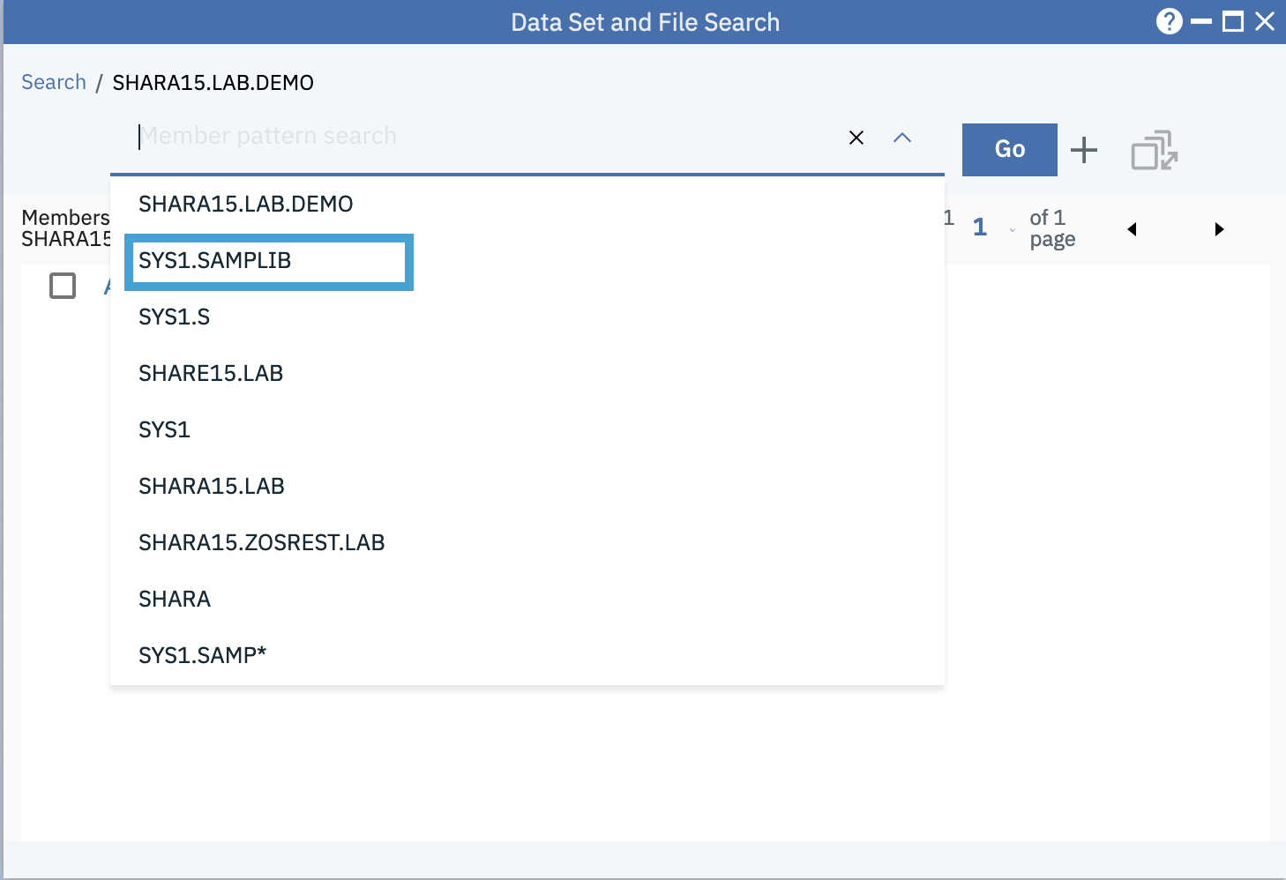

After the data set name SYS1.SAMPLIB is populated in the input box, click Go button or press Enter to list the data set.

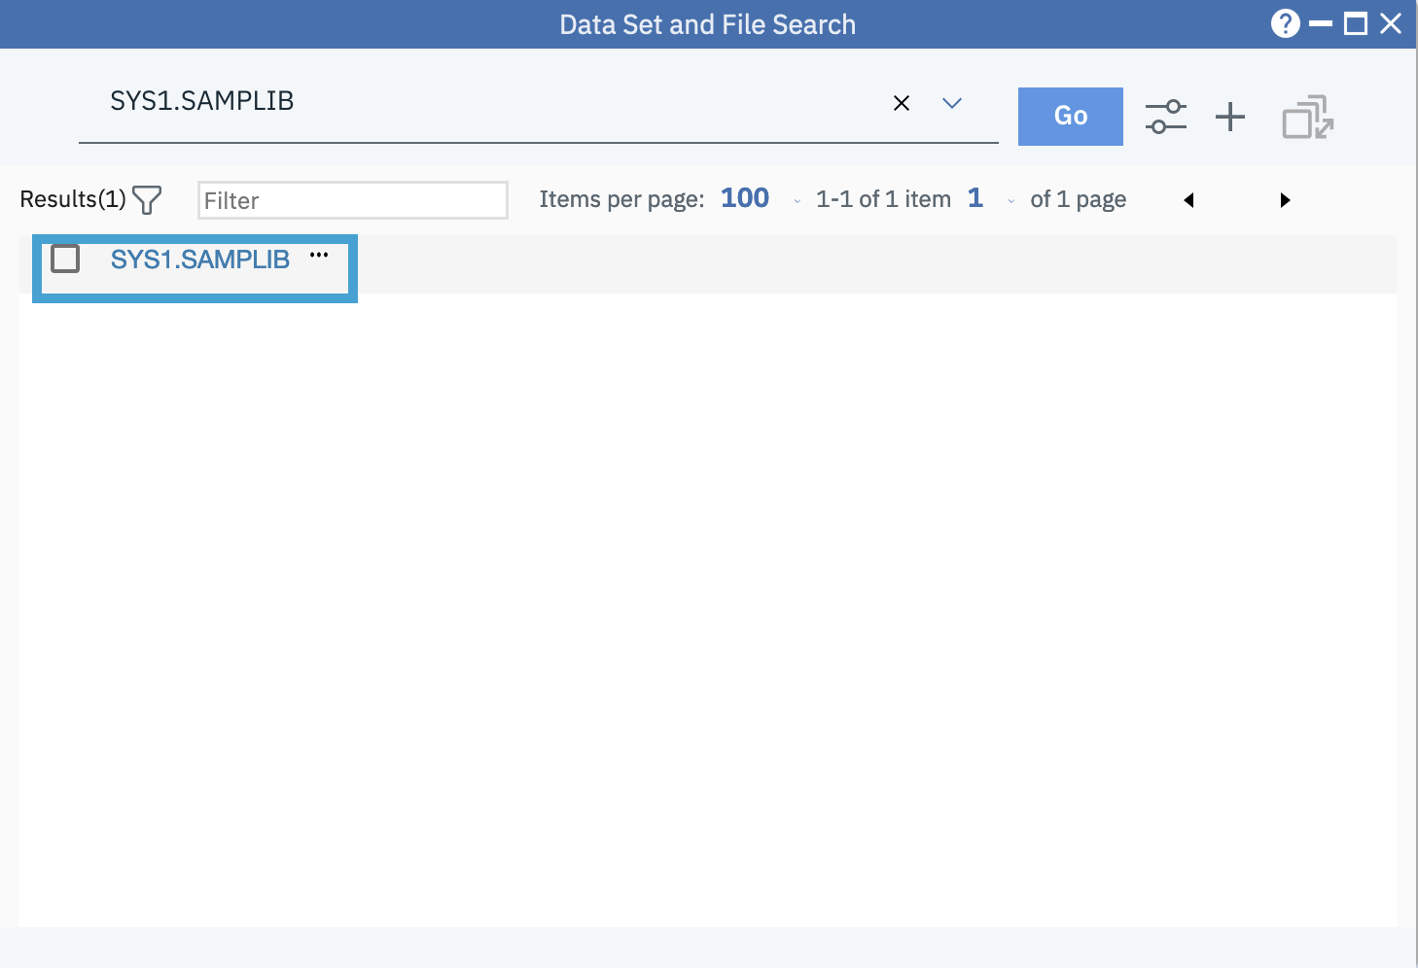

Click on the data set name to open member list of SYS1.SAMPLIB. Then enter “JCL” in the Filter input box on tool bar like below.

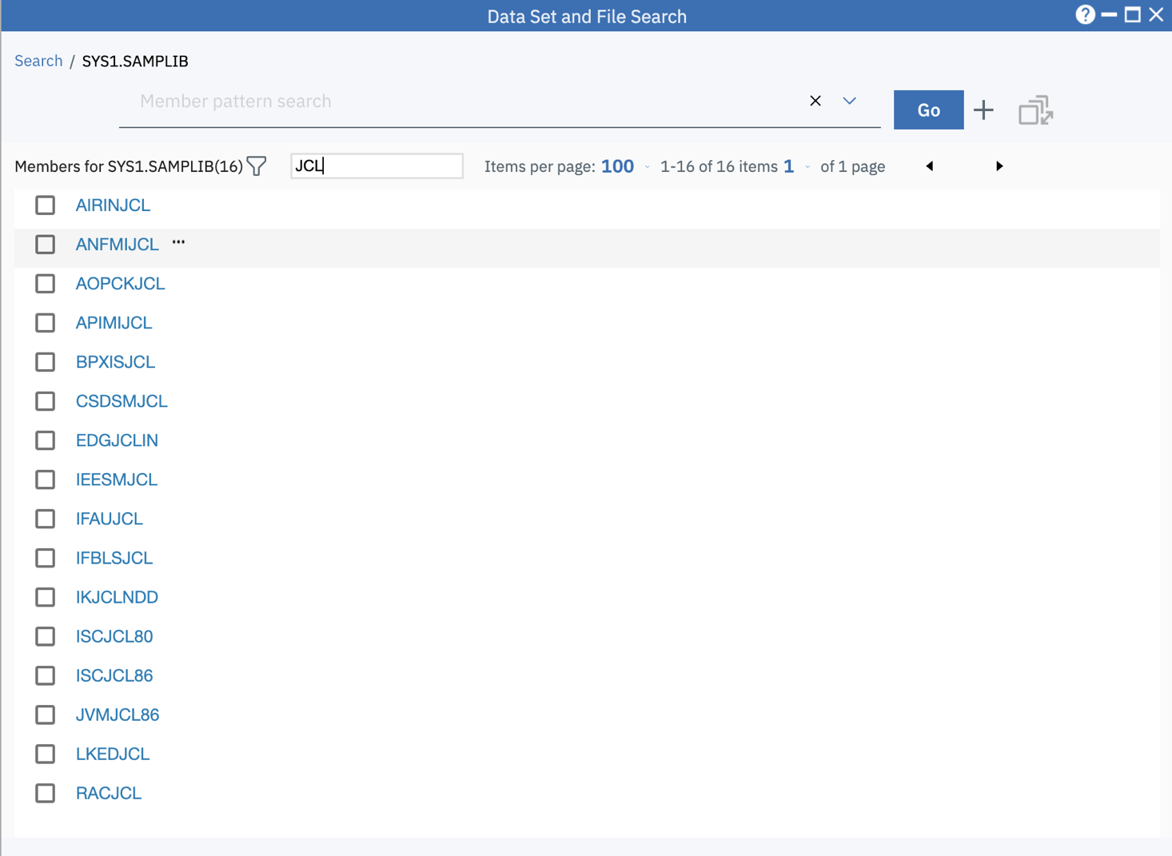

Step 6c. Compare two members

Right click on member name “AIRINJCL”, select menu “Compare with SHARA15.LAB.DEMO(AIRIN2)”

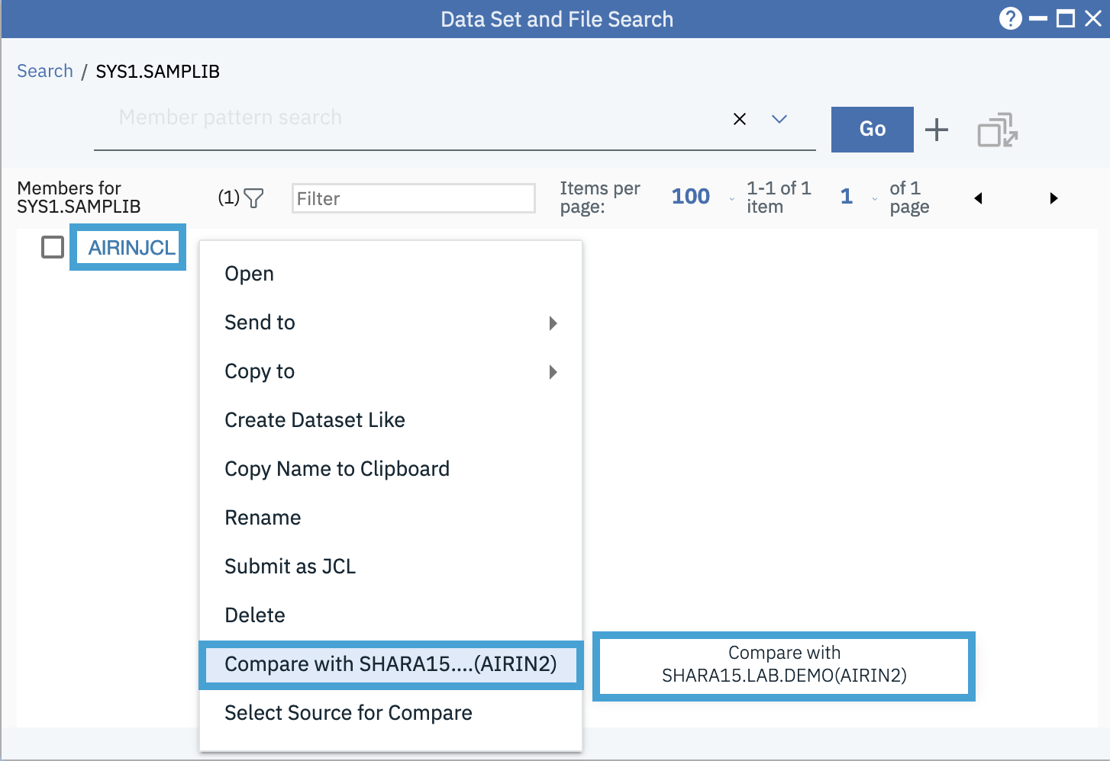

A compare window will be opened like below.

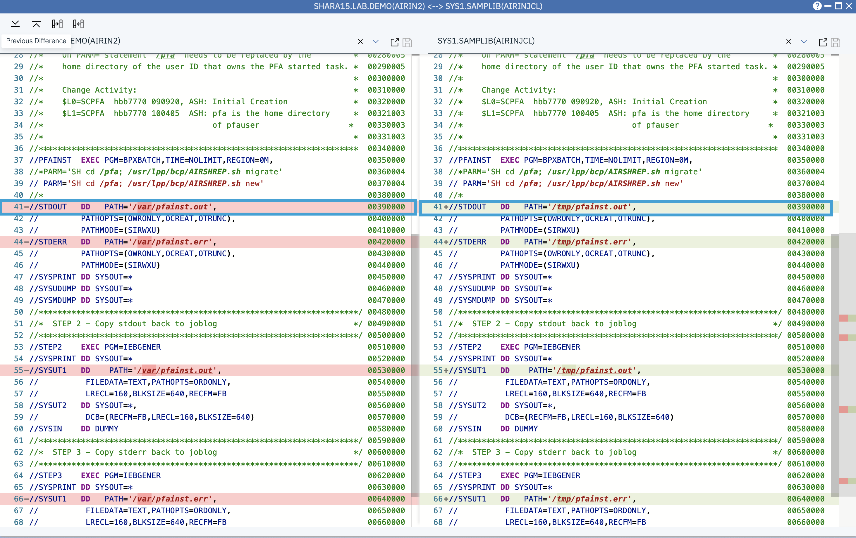

Step 6d. Copy the first difference from right to left

Now we are at the first difference, click the Copy to Left button on the top left to copy the current difference from right to left.

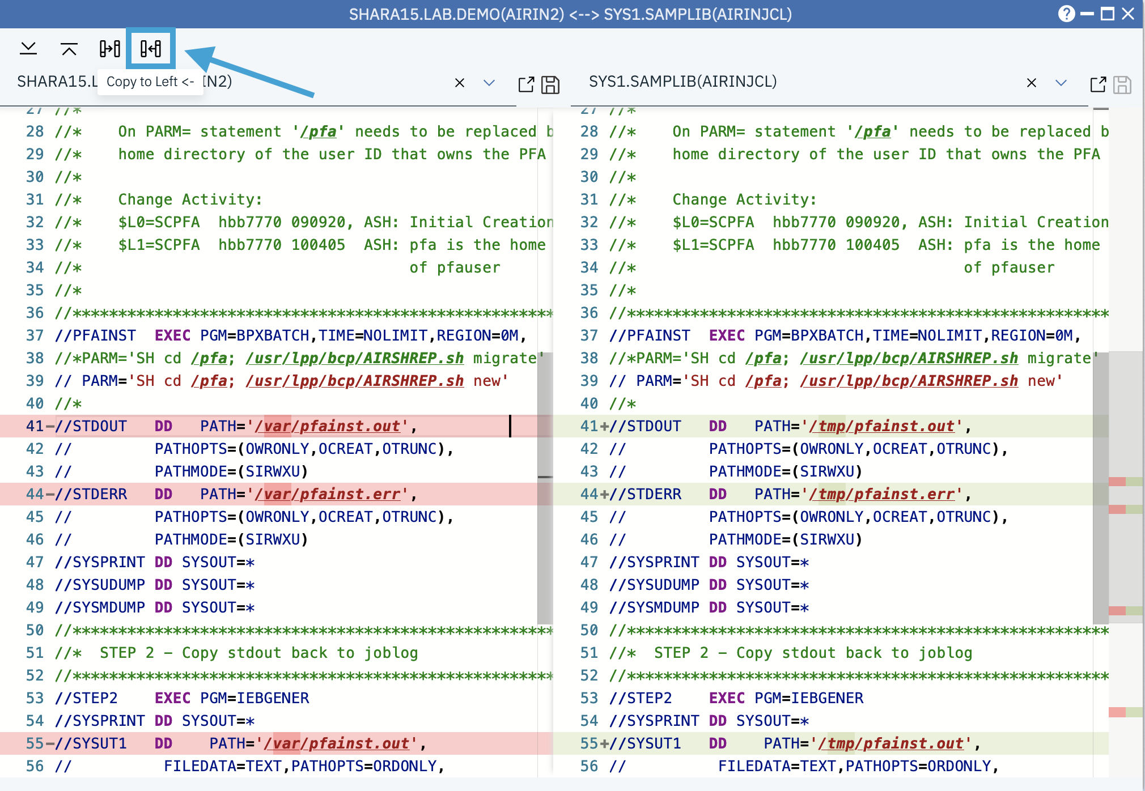

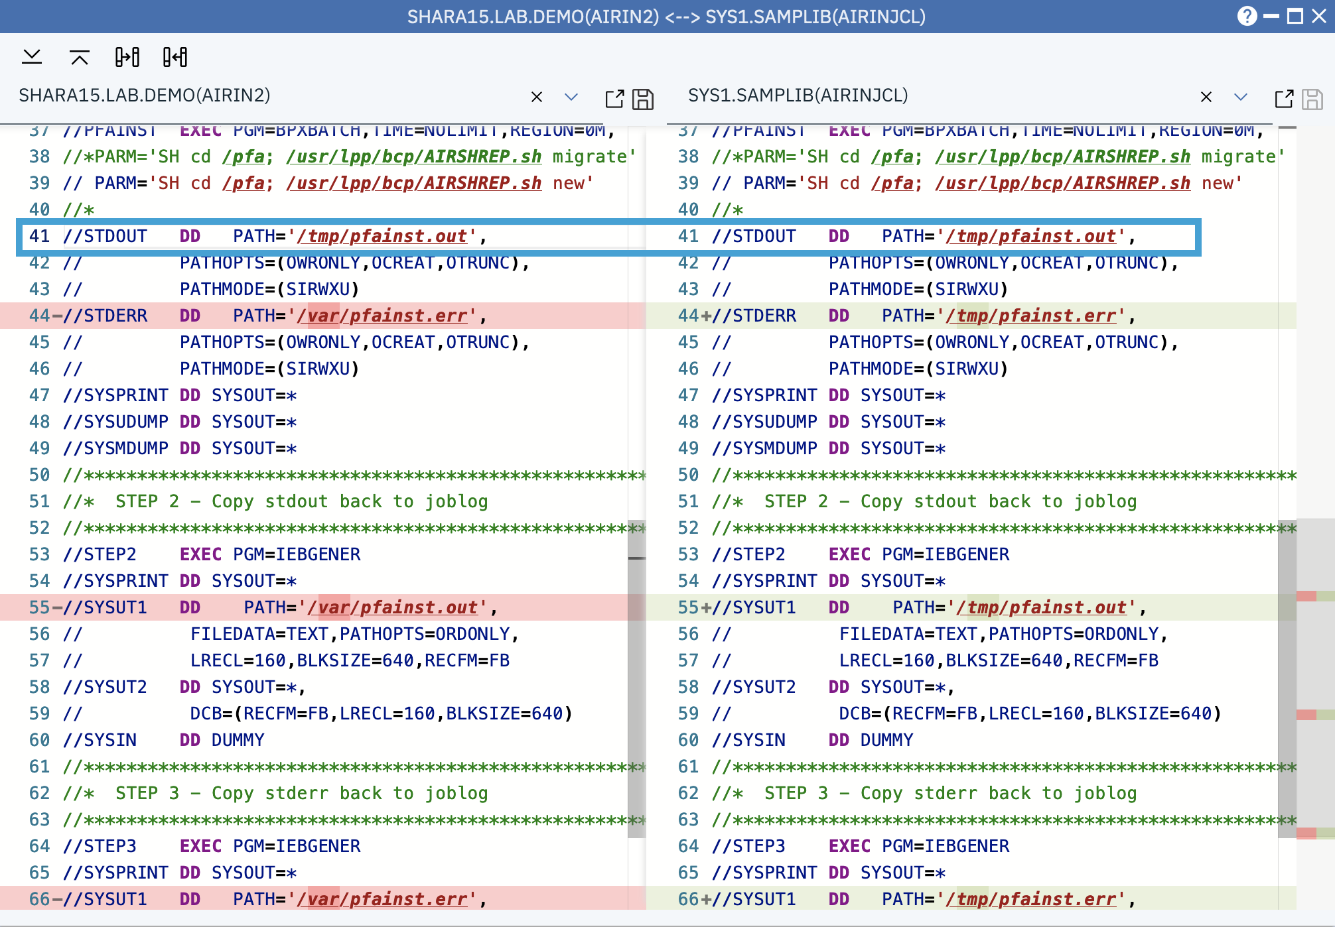

Step 6e. Copy the difference from left to right.

To change the third difference at the right side, we can either use the Next Difference button to navigate to it, or simply put the cursor at the third difference, and click the Copy to Right button.

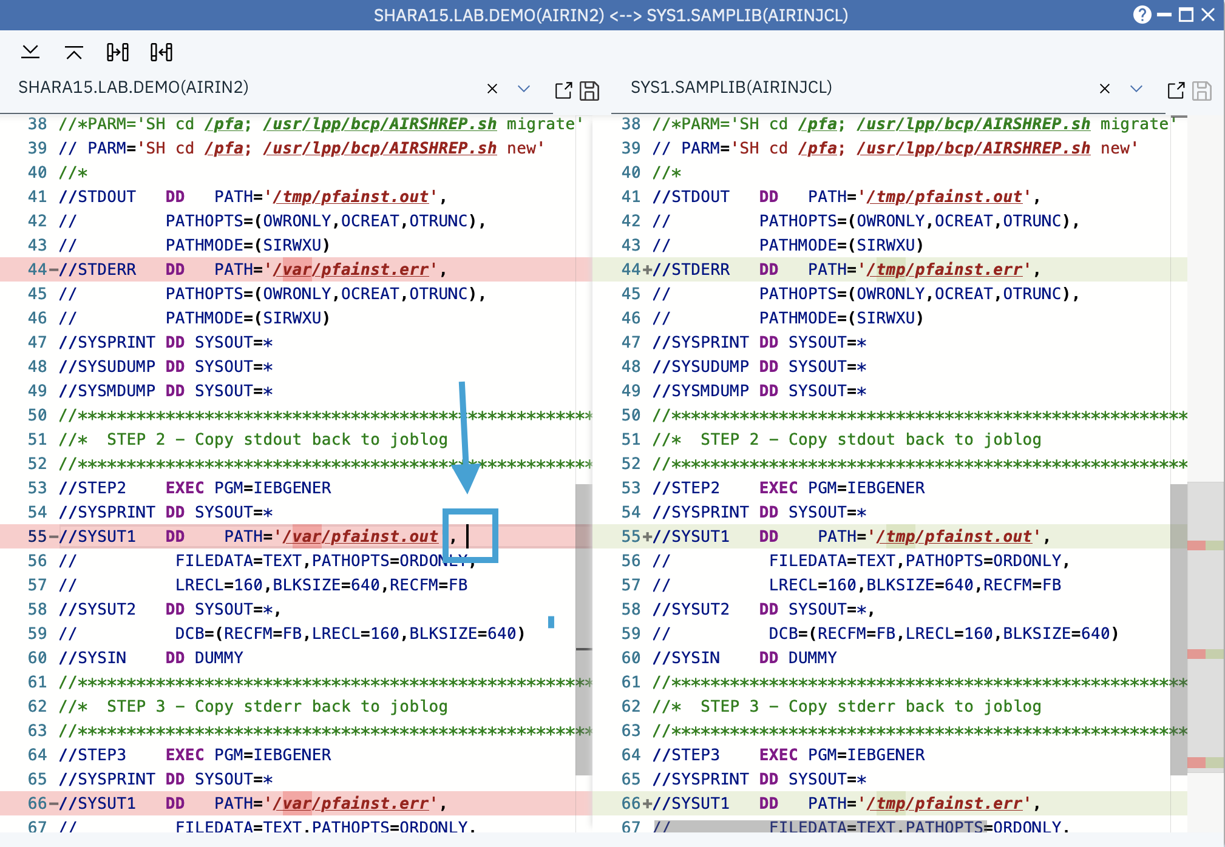

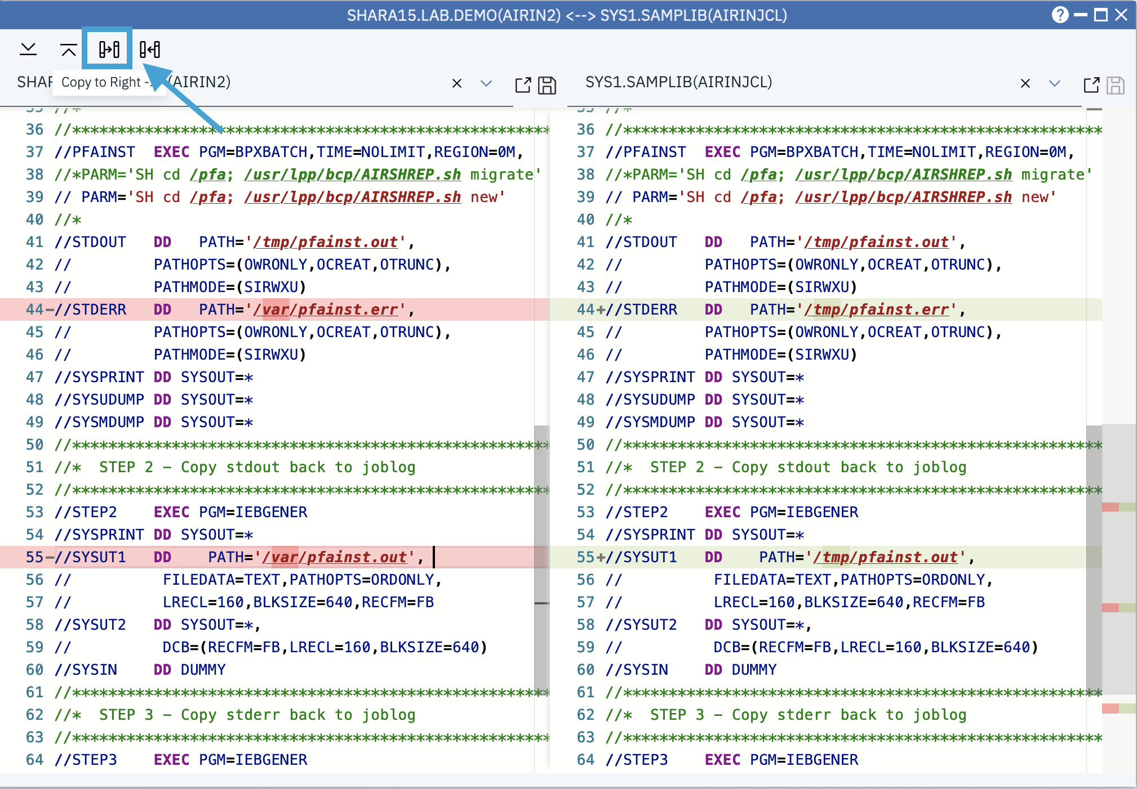

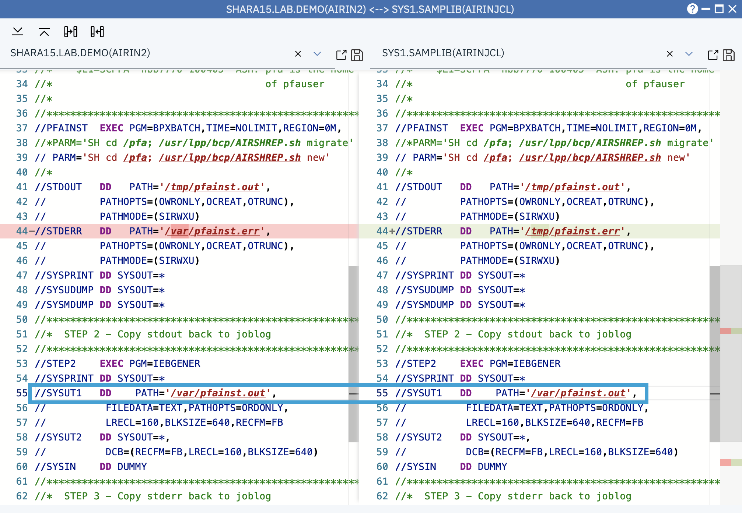

Step 6f. Save the changes.

Since you made changes to both sides, the Save icon on the top will now be enabled. Click the Save icons to save the changes.

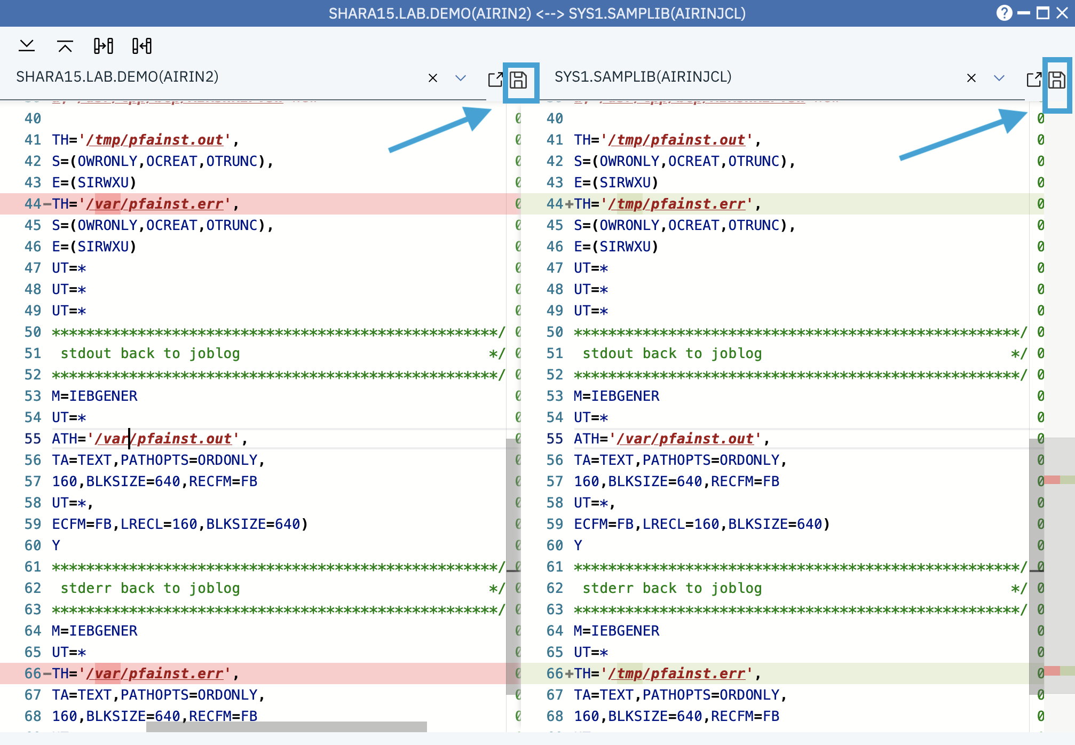

1. Browse USS path and edit USS file

Step 7a. Browse a USS path

* Switch back to the Data Set and File Search window.
* Input the USS path /global/zosmf/configuration/servers/zosmfServer in the search bar. You don’t have to enter the full path. Enjoy the type ahead search if you pause one second as you type.
* Click the Go button or press Enter to open the directory.

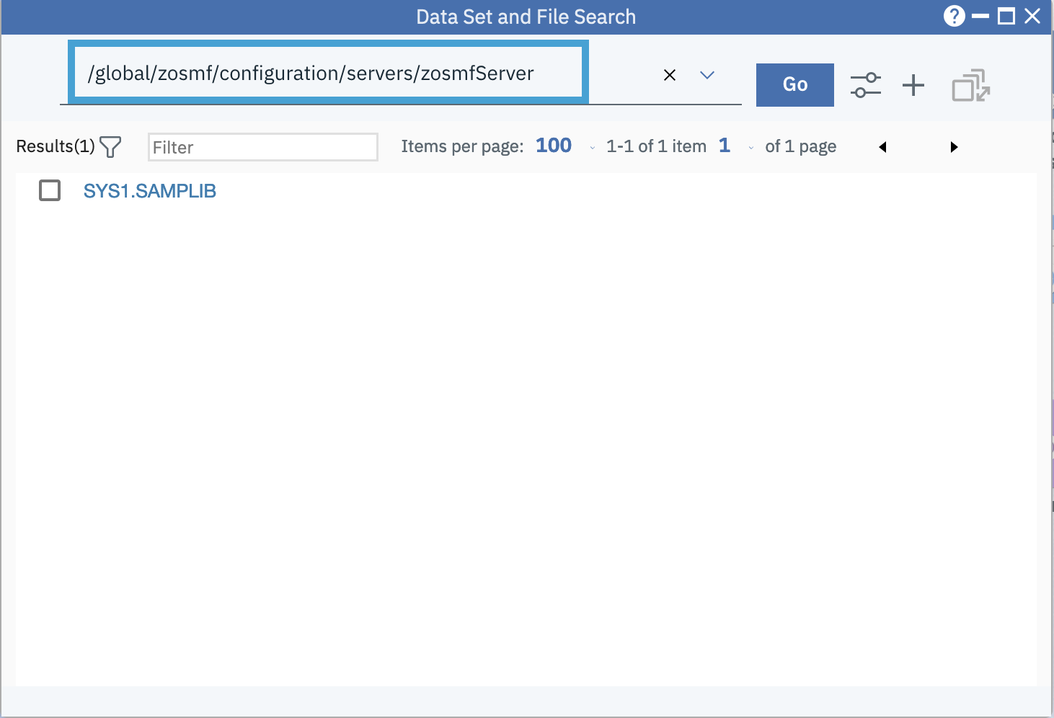

Click on the column header “Name” to sort the files alphabetically by name, then we can easily find the file server.xml

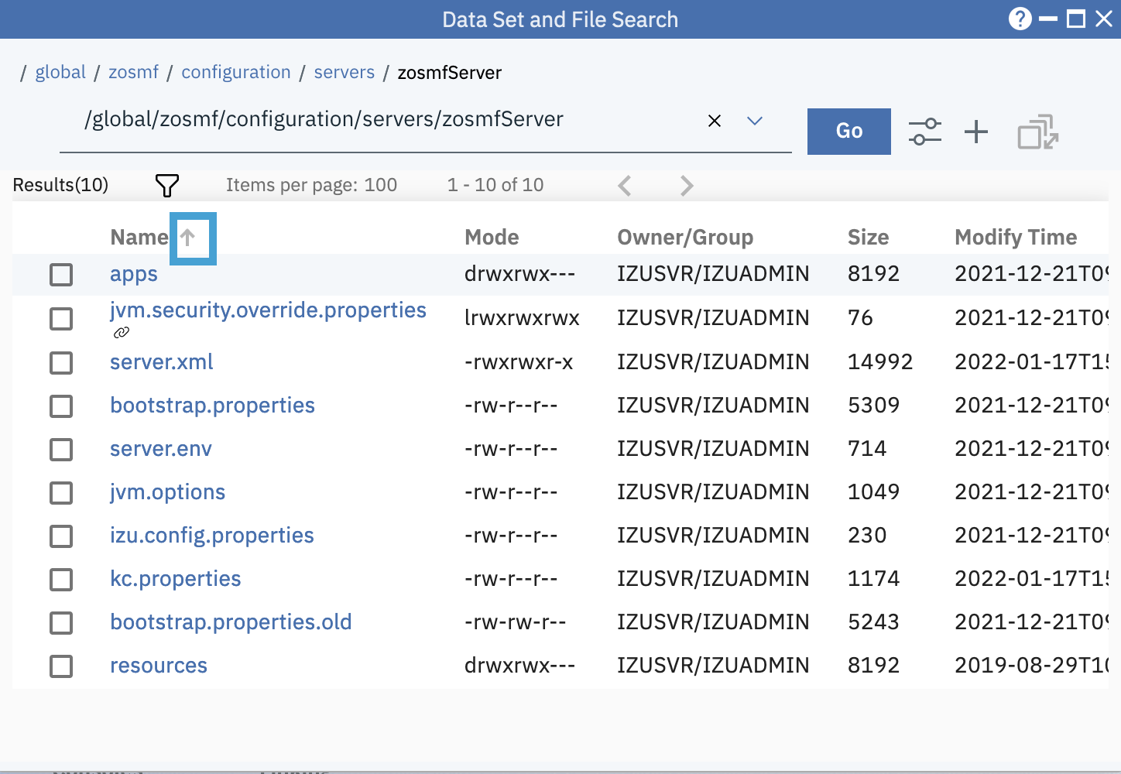

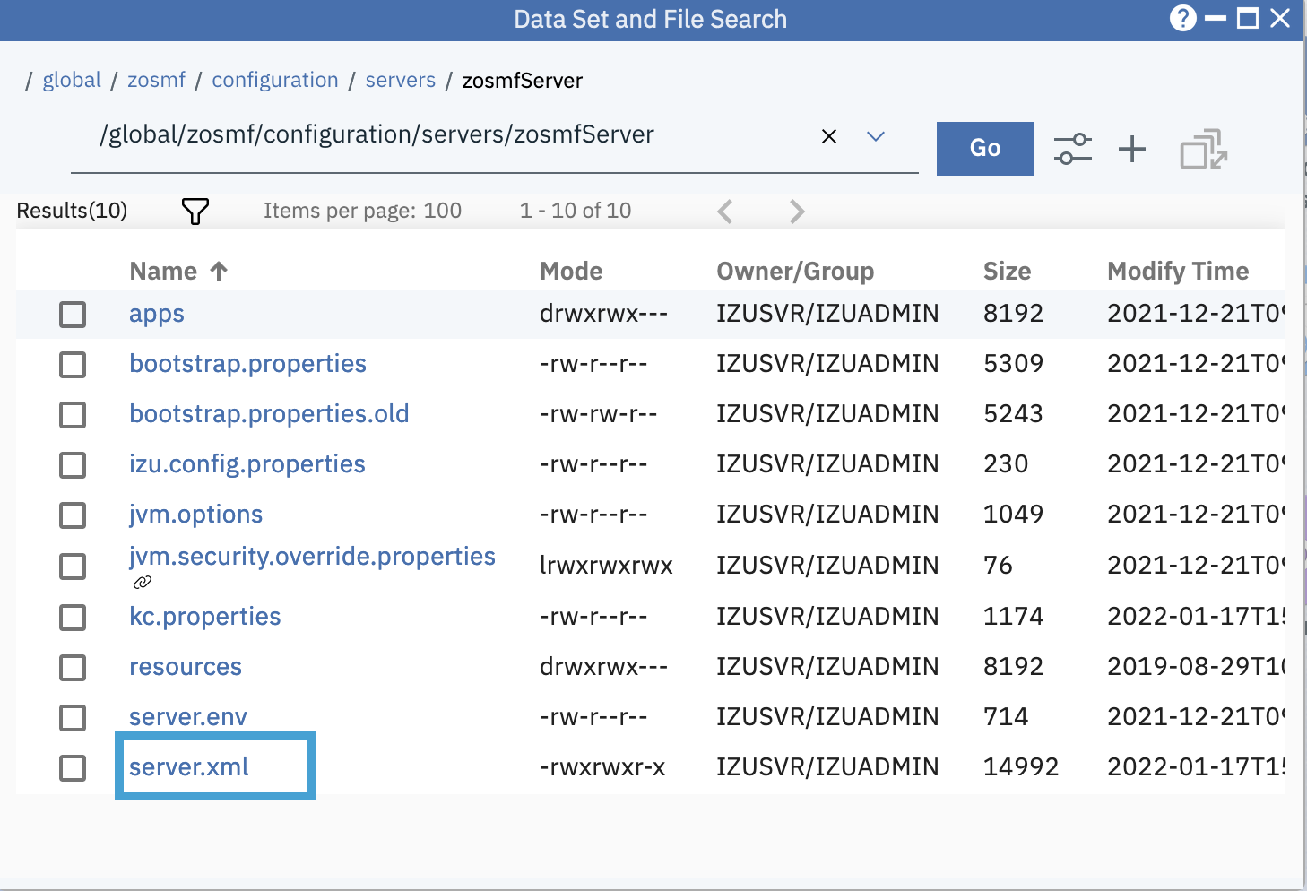

Open the USS file server.xml by clicking its name, we will see the file is opened and it’s also highlighted with XML syntax.

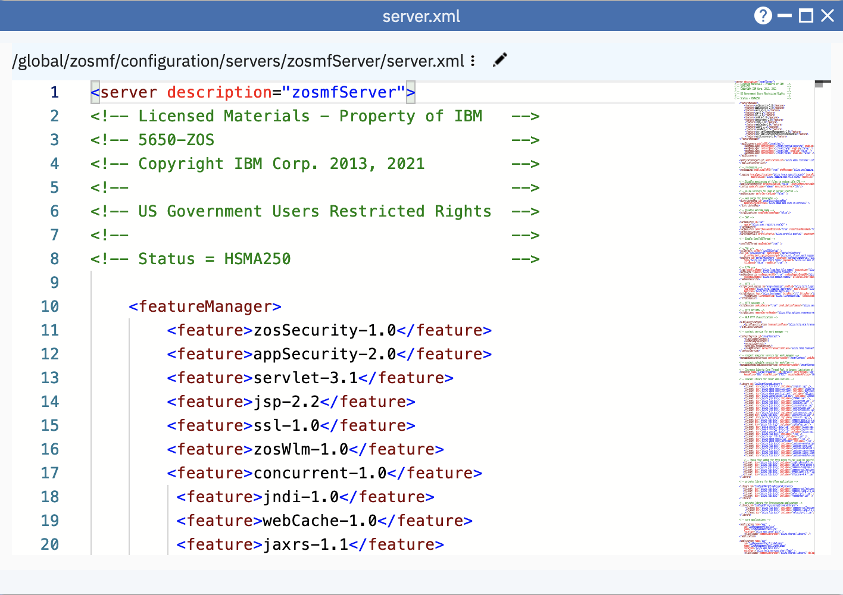

1. Open referenced data sets in Editor

Step 8a. Open the data set member SHPLEX.PROCLIB(IZUFPROC)

Switch back to Data Set and File Search window, search the data set SHPLEX.PROCLIB.

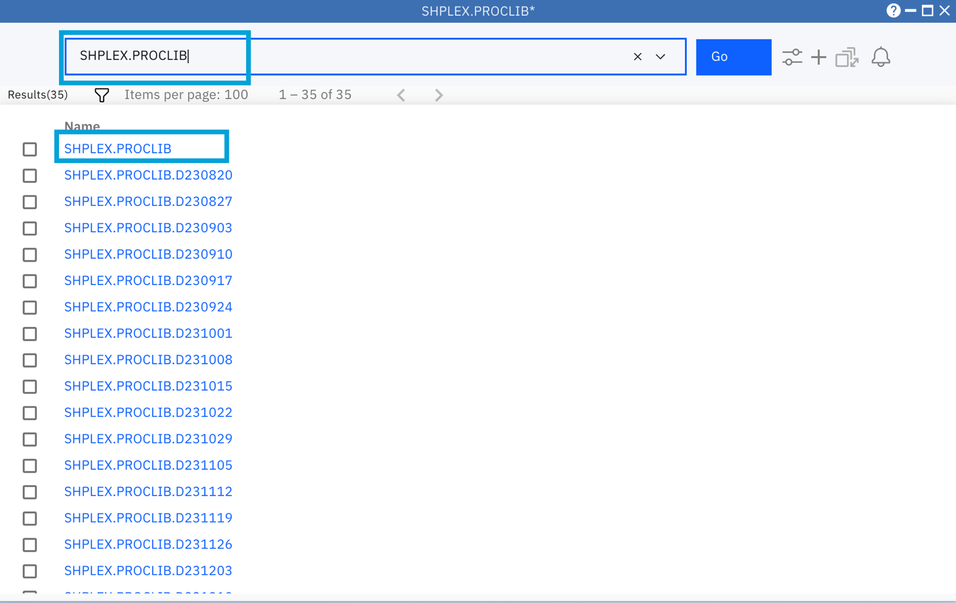

Click on the name of “SHPLEX.PROCLIB” to open its member list. Then input IZUFPROC in the search box to search for the member.

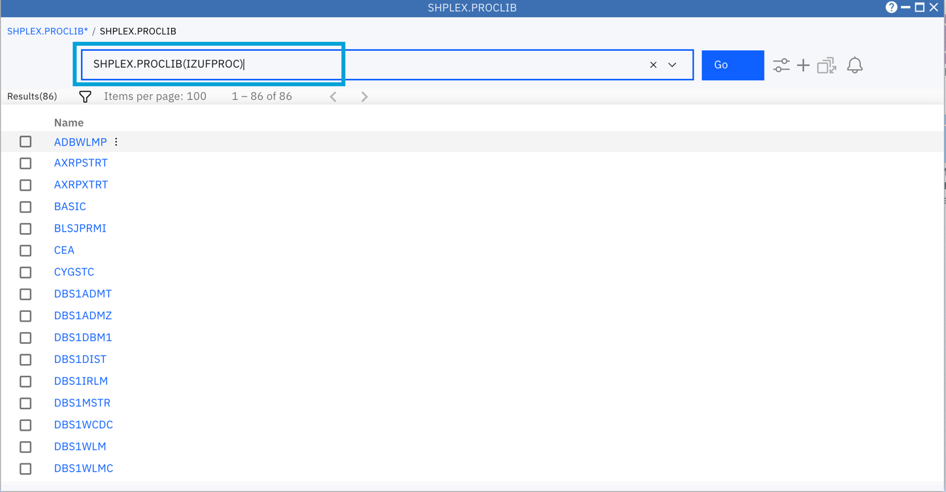

Open the data set member “IZUFPROC”, you will see the referenced data sets or USS path are displayed as links.

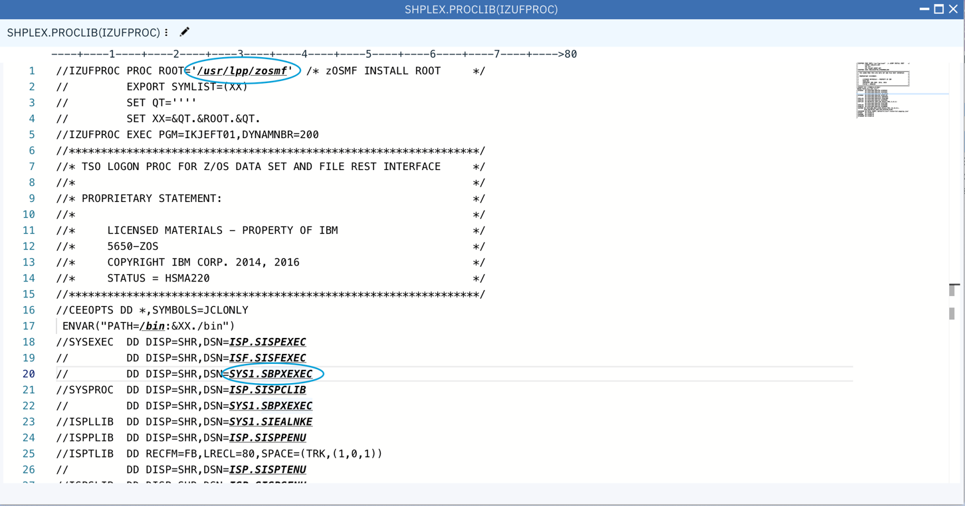

Step 8b. Adjust the window to a proper size

Click the maximize icon or double-clicking the window’s title bar to maximize the editor window.

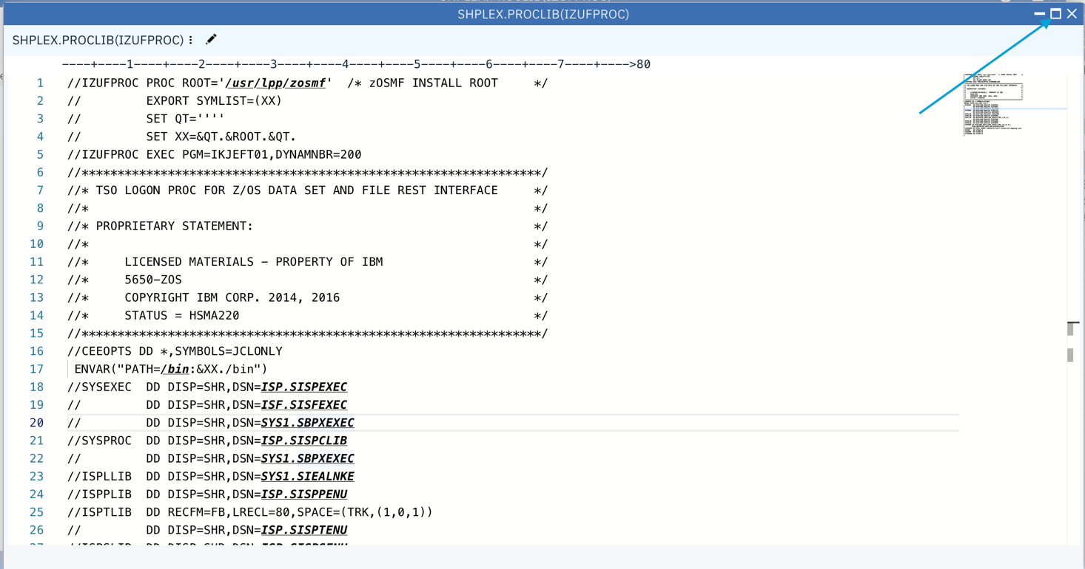

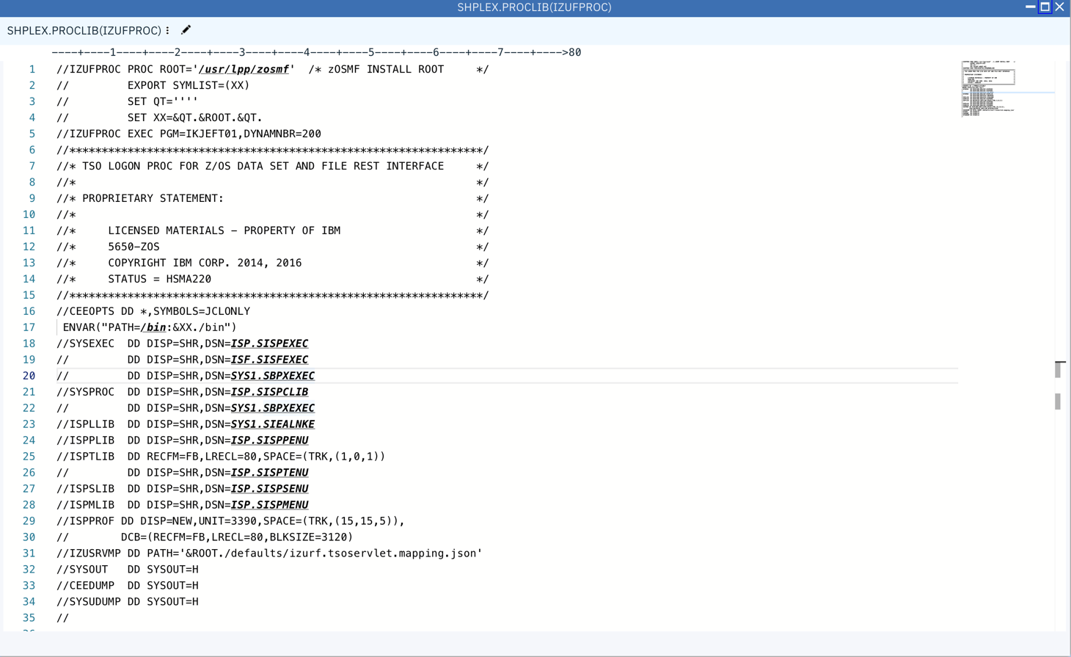

Step 8b. Open referenced data set with one click

* Hover on the name of SYS1.SBPXEXEC
  + For Windows, Hit Ctrl + Click to open the data set
  + For Mac, Hit Cmd + Click to open the data set

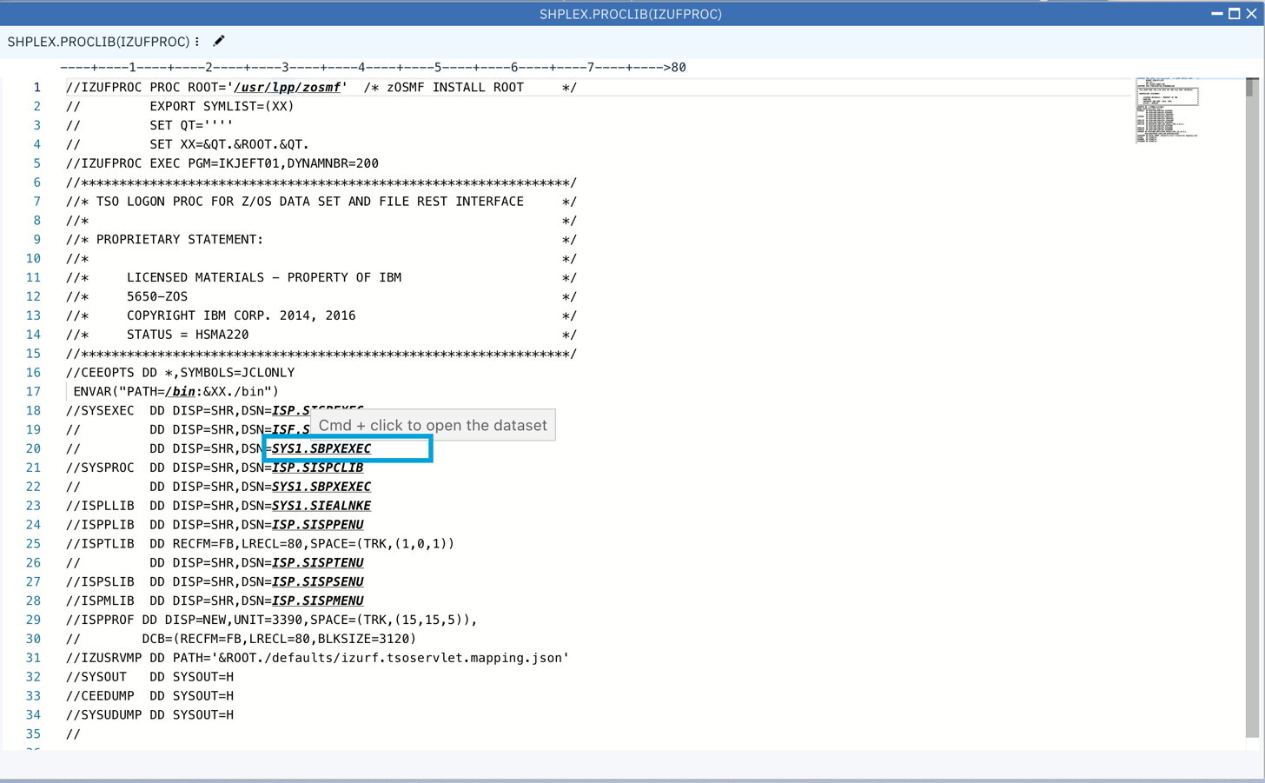

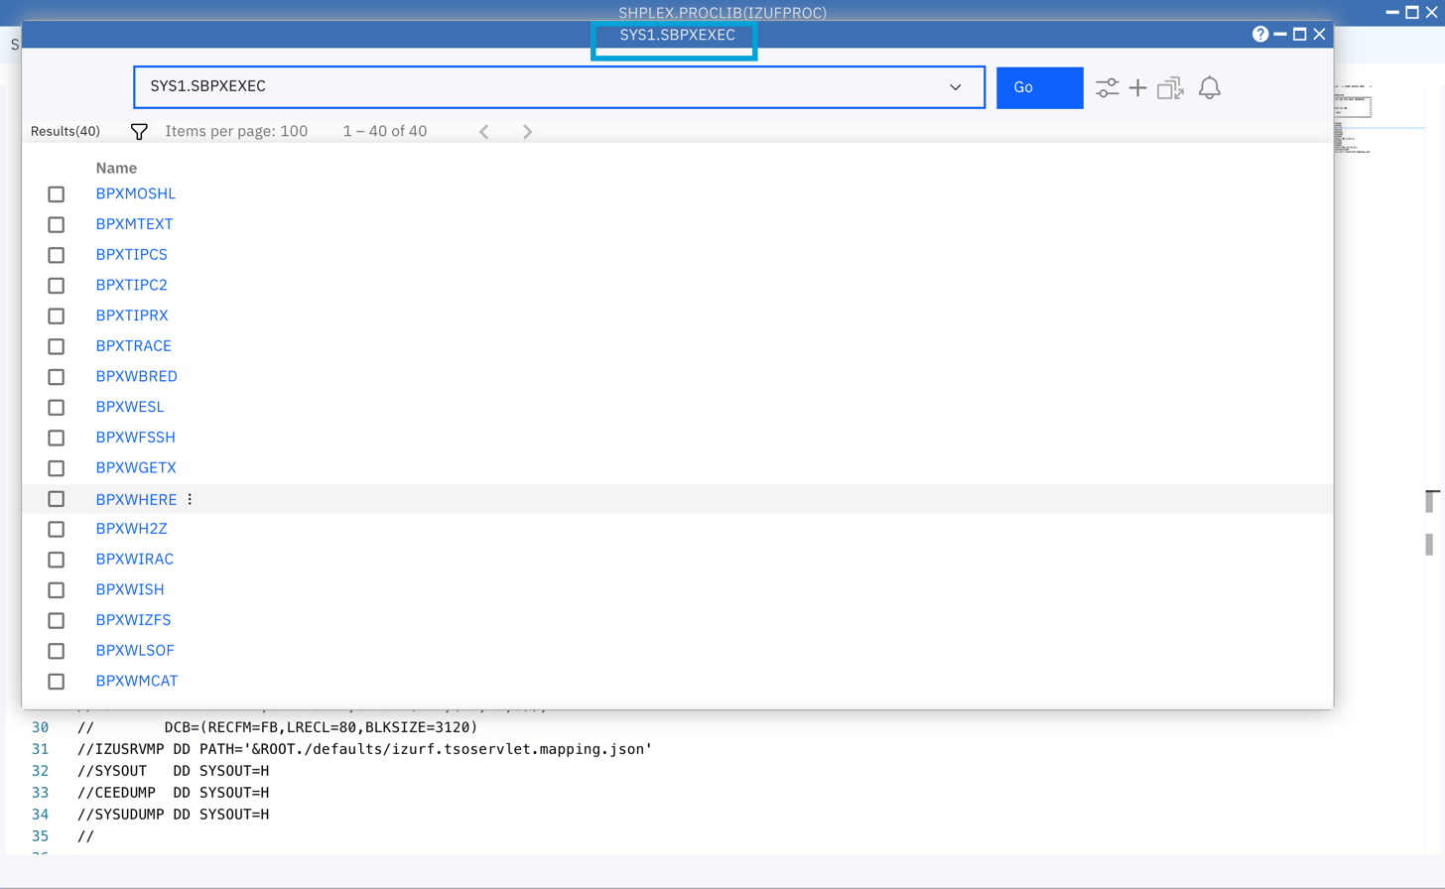

Step 8c. Open a referenced USS directory from Editor window

* Switch back to the window which displays content of SHPLEX.PROCLIB(IZUFPROC)
* Scroll up to the top of the content.
* Cmd+Click on usr/lpp/zosmf path

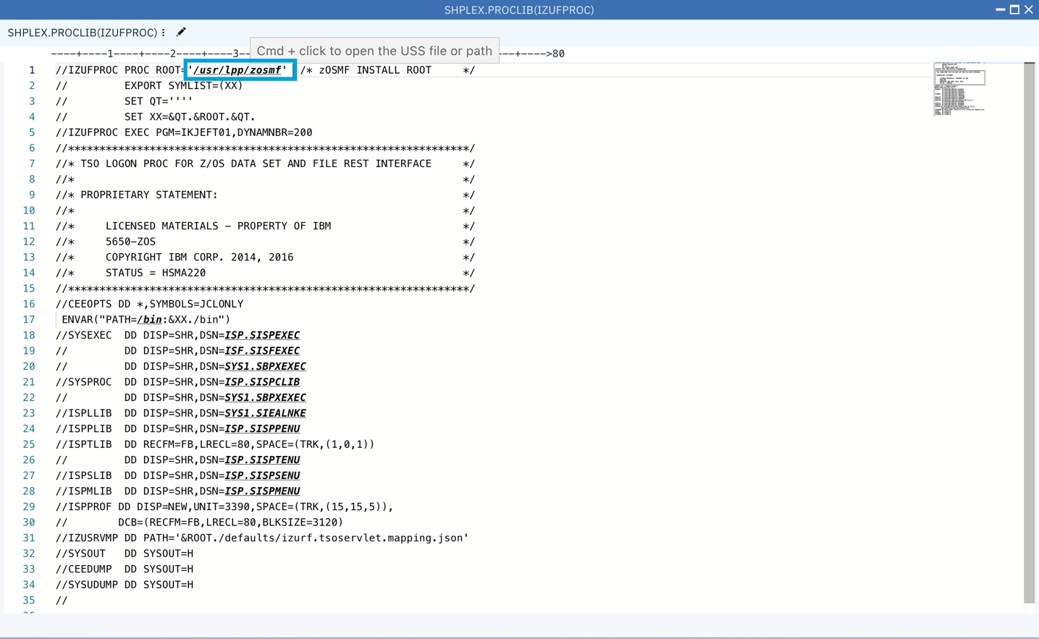

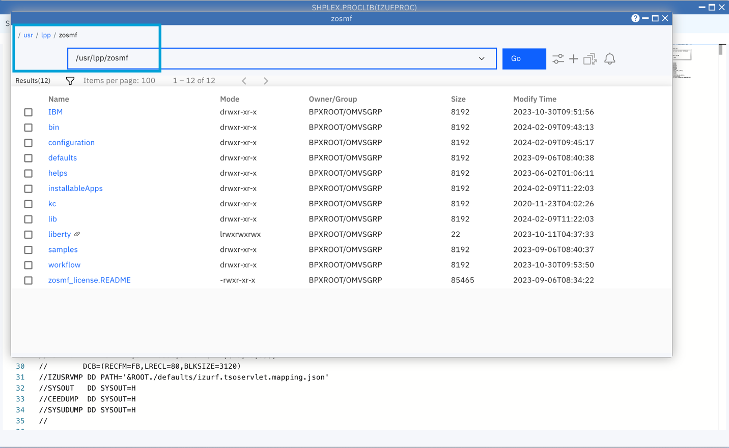

Now, let’s select “Data Set and File Search” window again. If you cannot find the window, you can open it via clicking on the “Search” icon on the right of z/OSMF task bar like below.

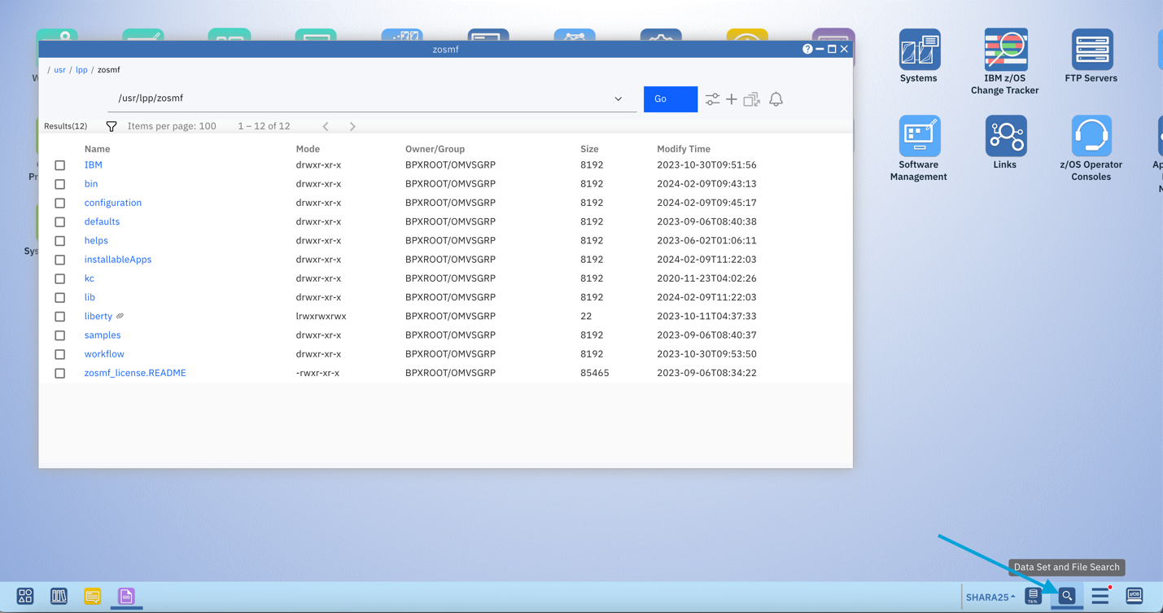

You can also right click on the Search icon to show the menu and then select “New Search Window” like below. Other options include show specific search window, close all search windows, etc...

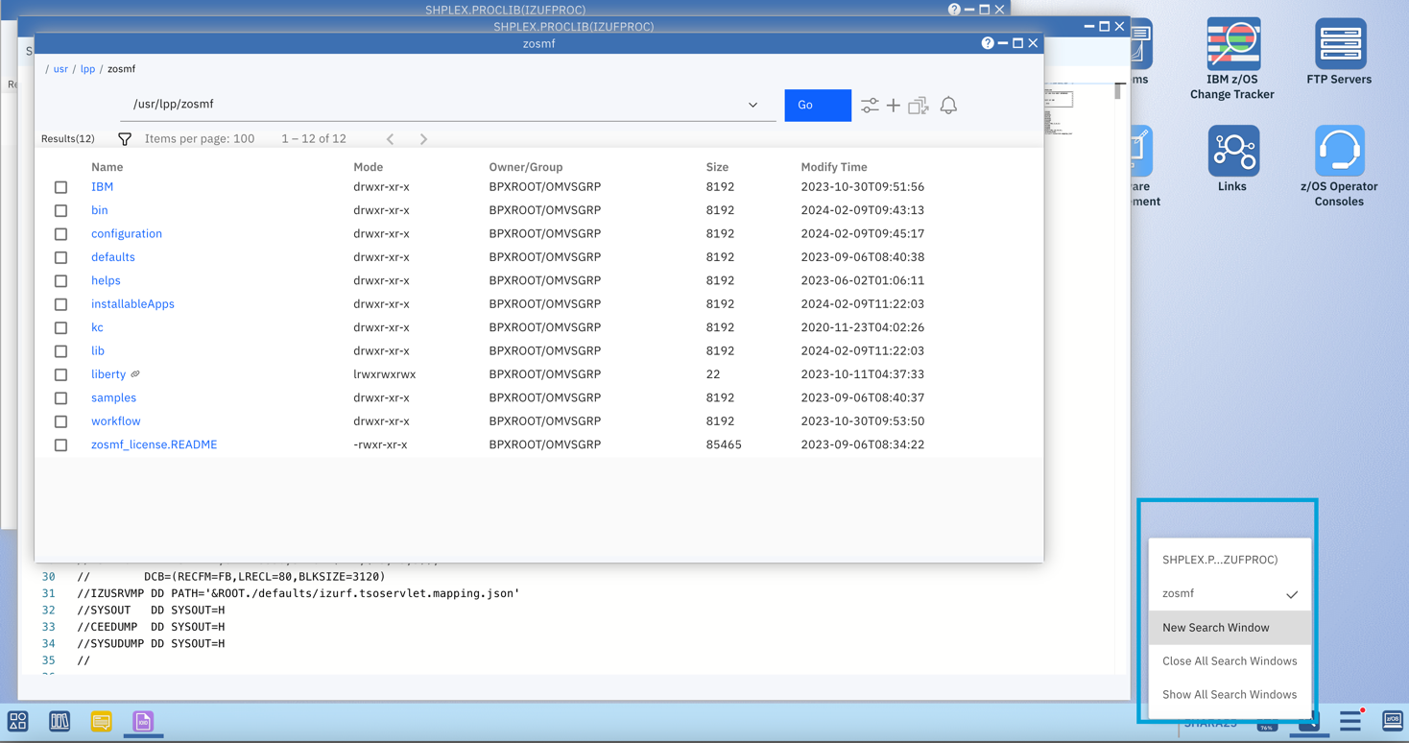

1. Create shortcut for data set or data set member

Step 9a. Find the data set member SYS1.SAMPLIB(IZUAUTH)

* In the “Data Set and File Search” window, enter SYS1.SAMPLIB and then hit Enter.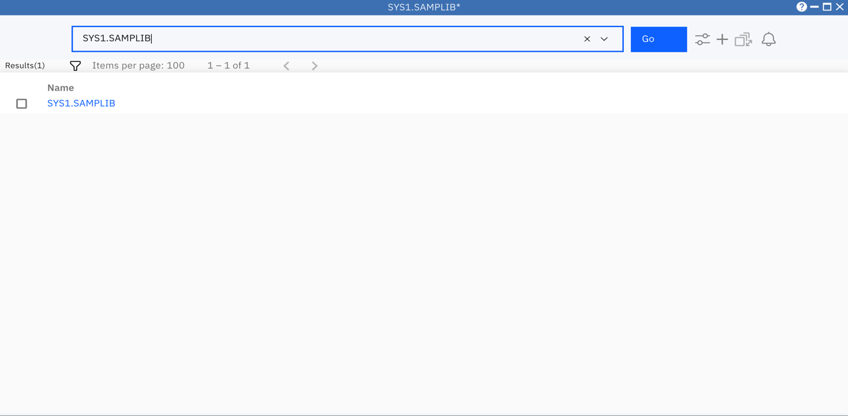

Open member list of SYS1.SAMPLIB by clicking on the name of SYS1.SAMPLIB. Then enter “IZUAUTH” in the Filter input box to quickly find IZUAUTH sample job.

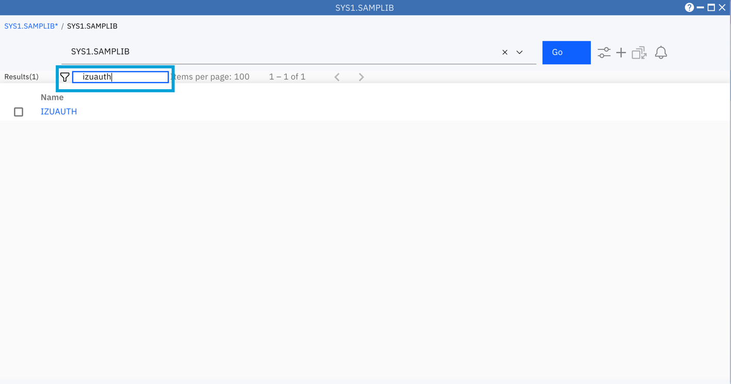

Step 9b. Send IZUAUTH to desktop

Right click on IZUAUTH à select Send to àselect Desktop.

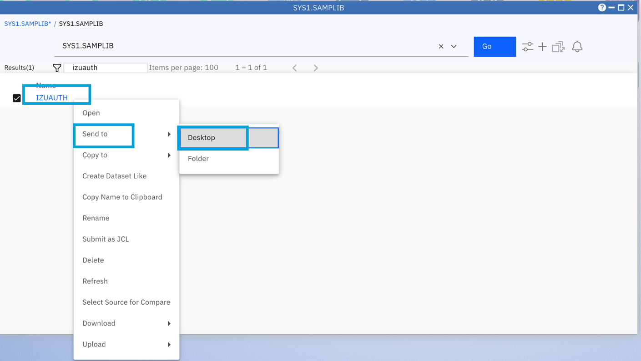

Step 9c. Check the shortcut

Double click on the background of z/OSMF desktop can quickly bring you back to the desktop. Then you will see the shortcut you just created for SYS1.SAMPLIB(IZUAUTH) on the desktop.

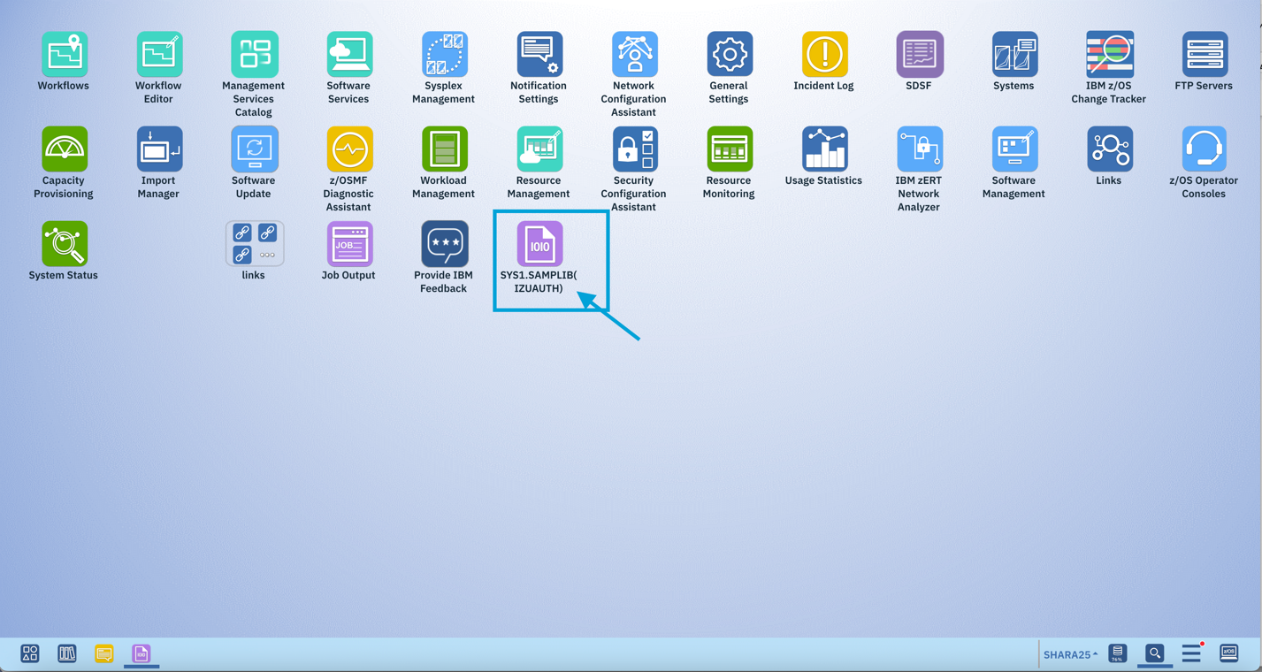

Step 9d. Open the shortcut

Double click on the icon of “SYS1.SAMPLIB(IZUAUTH)”, you can directly open the member for editing. The shortcut could help you to quickly locate some frequently used files or data sets in the future.

Step 9e. Submit job from z/OSMF Desktop Editor

* In the Editor window we opened for “SYS1.SAMPLIB(IZUAUTH)”, click on the 3 dots icon and then you will see a menu item “Submit as JCL”. Since you are operating with a shared system, we won’t perform this action. But if you do so, a separate Job Output window will be popped up for you to check job outputs.

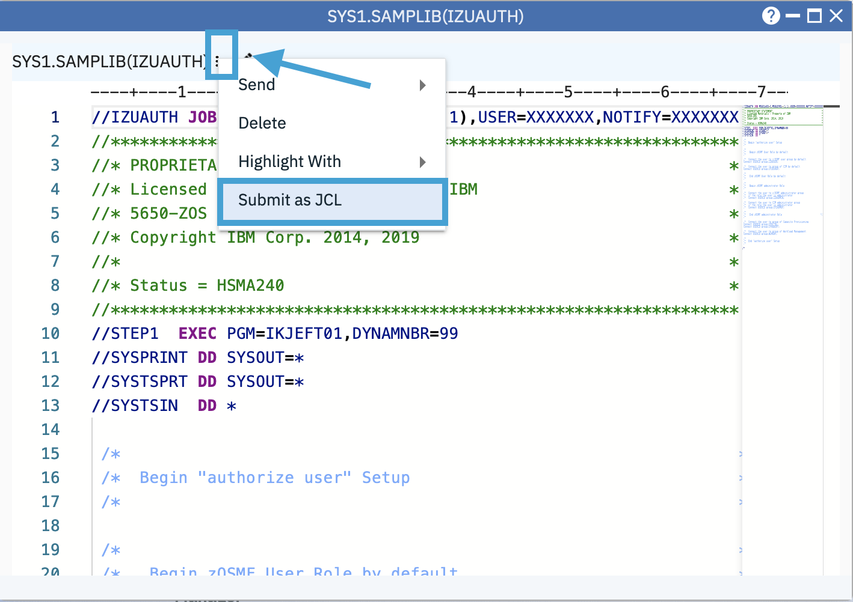

1. Download/Upload Data Set, Data set member, or USS file

Switch back to Data Set and File Search window, clear “IZUAUTH” in Filter, and input “IZUSEC” in the Filter box.

Step 10a. Download SYS1.SAMPLIB(IZUSEC)

Right click on IZUSEC -> select Download

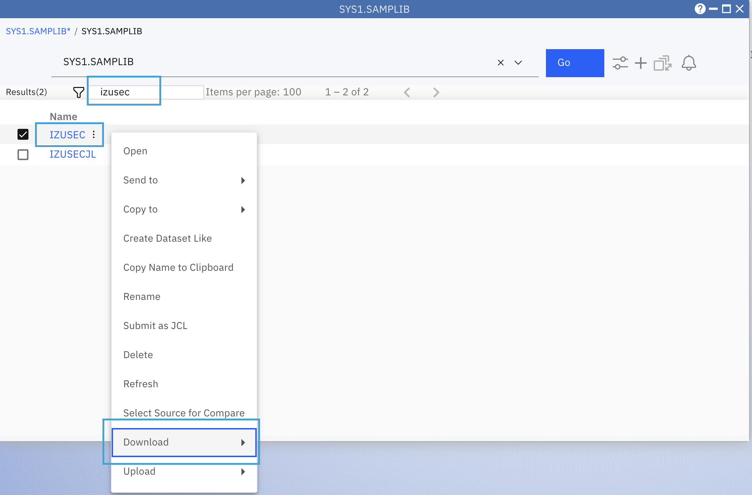

The IZUSEC member will be downloaded to your local machine.

Step 10b. Upload local file to z/OS

Switch back to the Data Set and File Search window, input the USS path /tmp/. Hit Enter key or click on “Go” button.

Right click on the anywhere of the result list and then select Upload menu

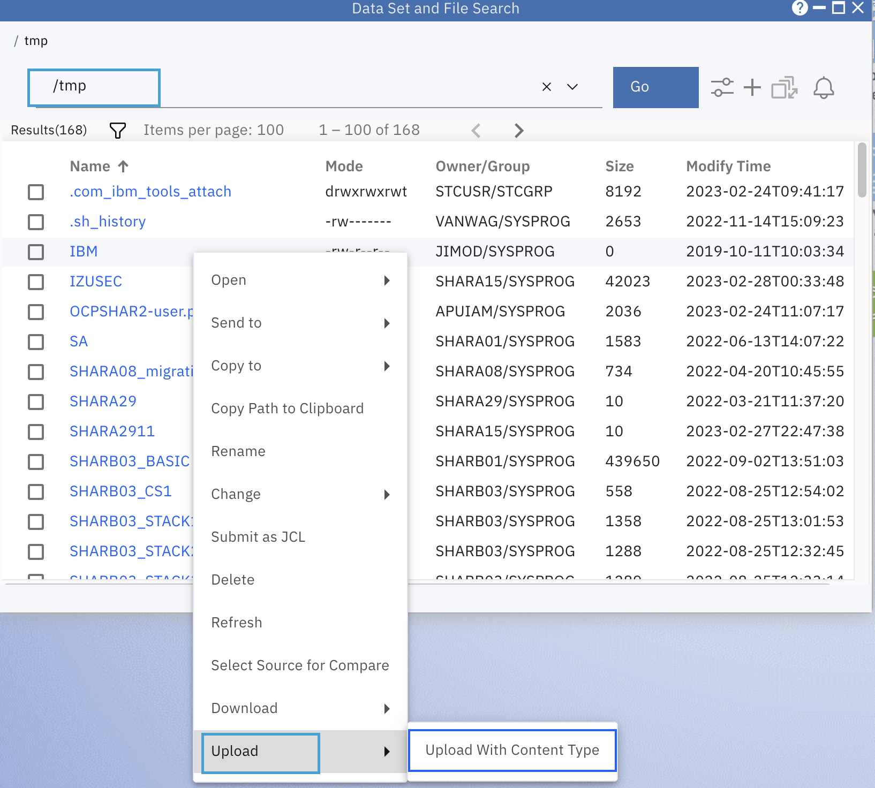

Find out the downloaded IZUSEC from your local machine, select it, then click on OK button. Since we have prepared a IZUSEC file under /tmp/ directory before lab session,

you will be asked to rename the file, please rename the file like <userid>_IZUSEC, <userid> should be your current logon user id, and then click OK button.

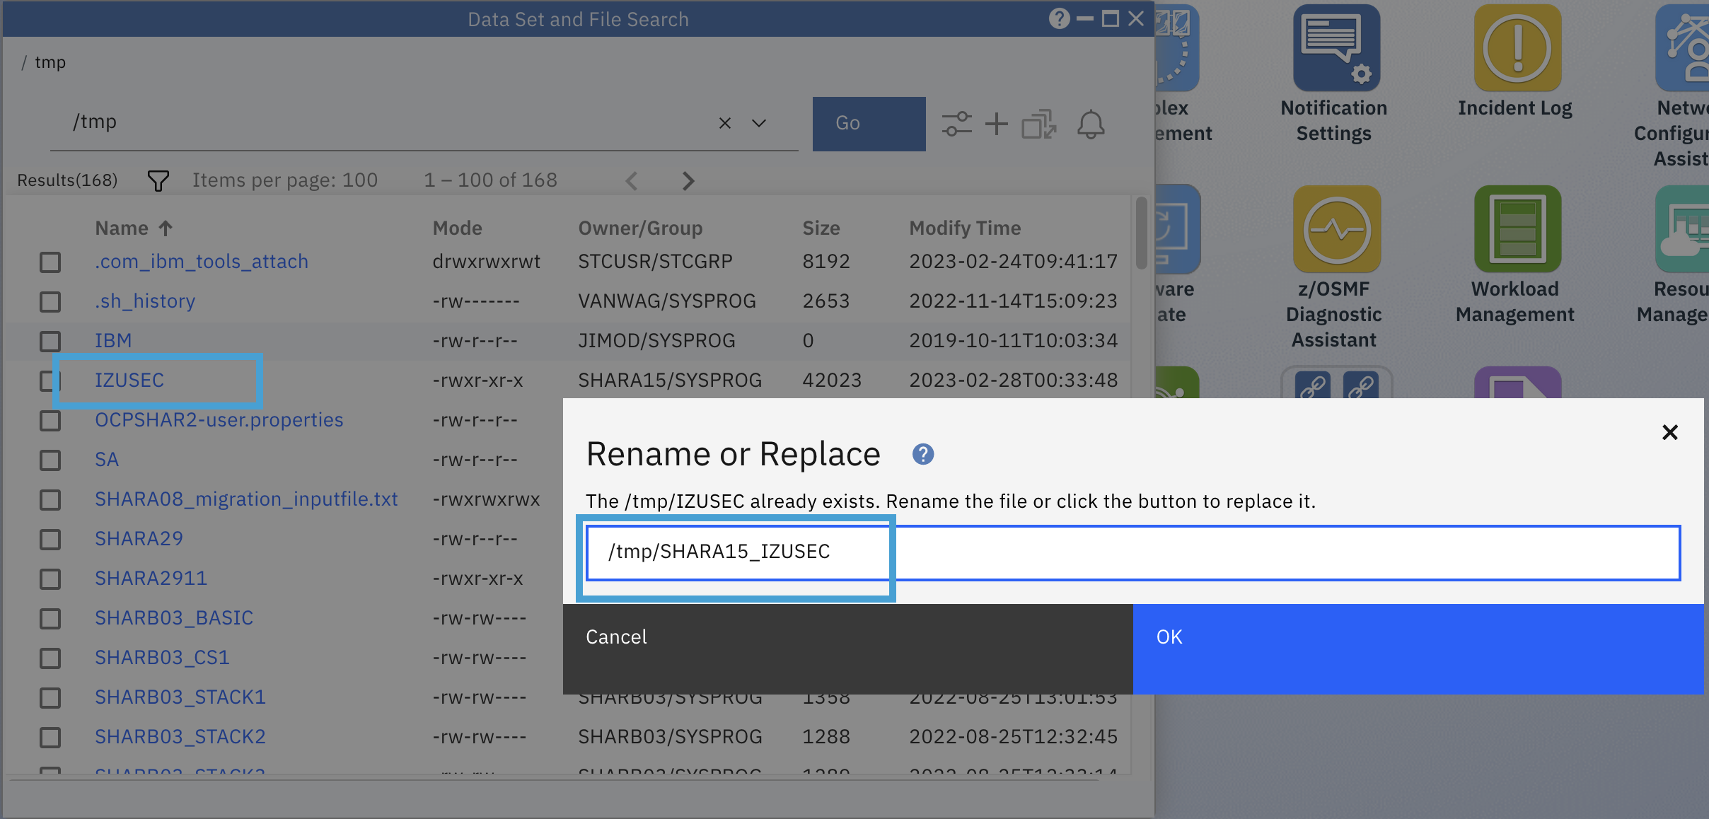

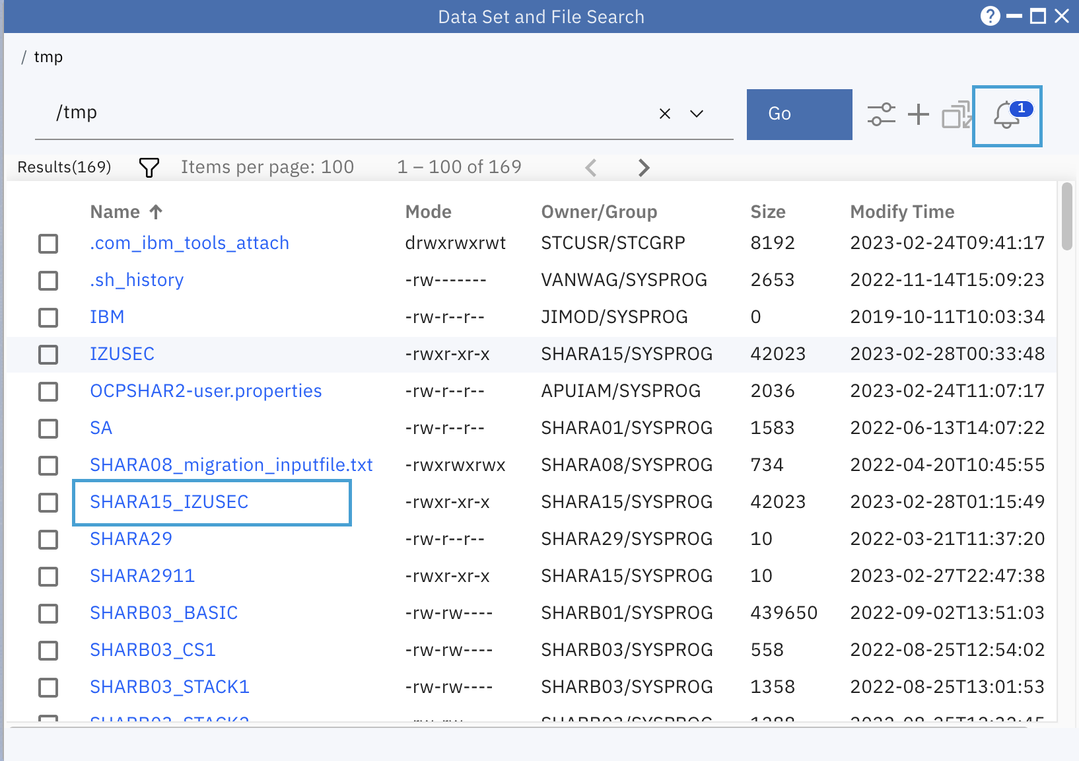

You will find the file has been uploaded to /tmp/ directory. You will also get below notification message:

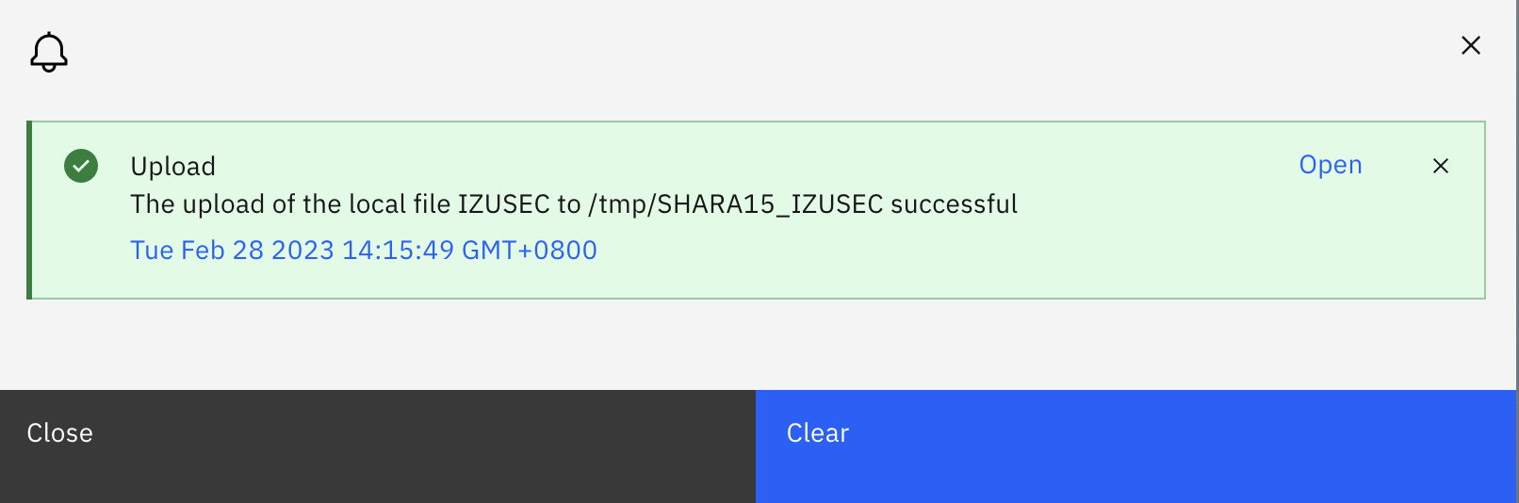

Step 10c. Remove the file you just uploaded

Select the file <userid>_IZUSEC you just uploaded, right click and select Delete to remove it.

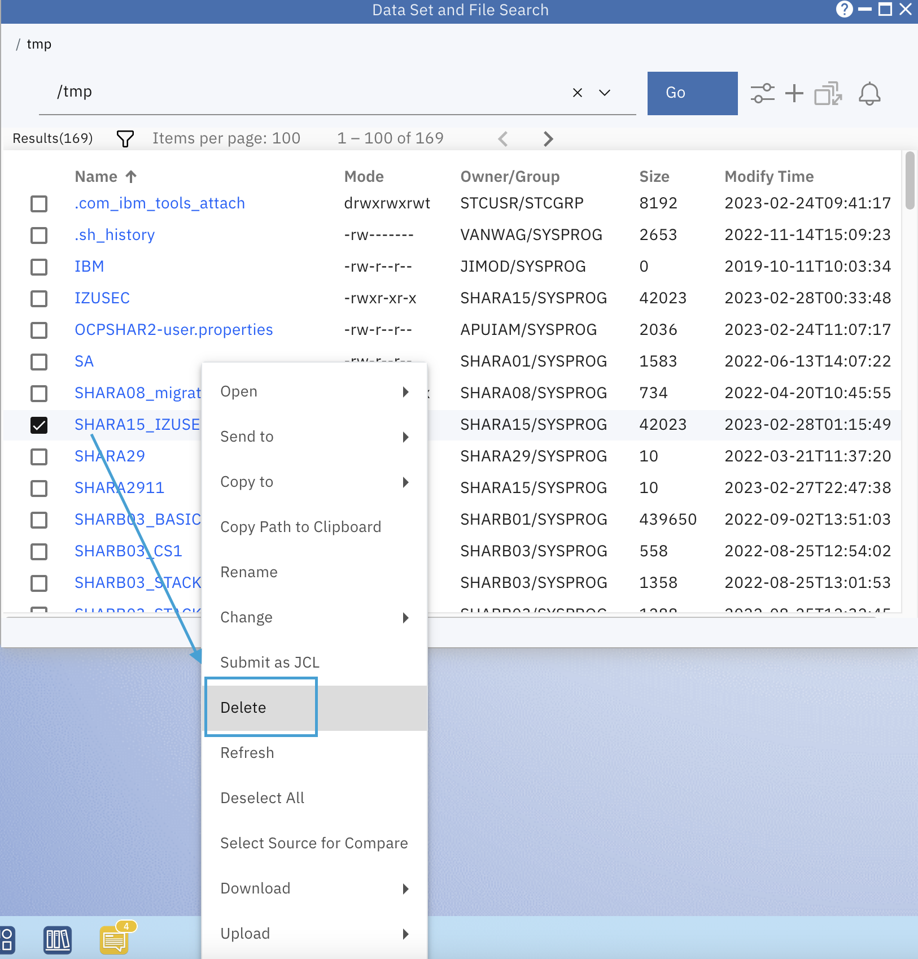

#### End of exercise

